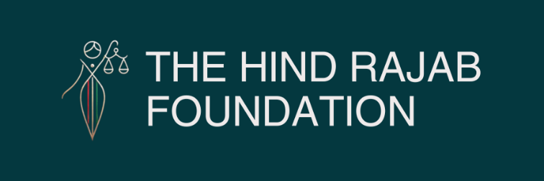

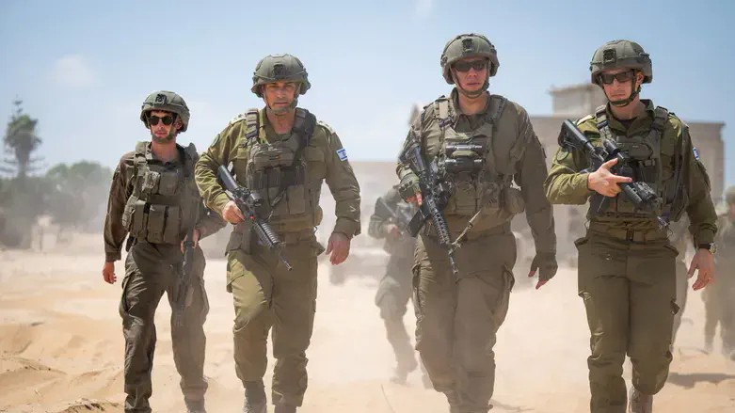

Picture taken on 21 August 2025 in Khan Younis: IDF Chief of Staff Lt. Gen. Eyal Zamir alongside Southern Command Commander Maj. Gen. Yaniv Asor and 36th Division Commander Brig. Gen. Moran Omer

On 25 August 2025, Israel struck Nasser Hospital in Khan Younis twice, killing 22 civilians — including journalists, doctors, rescue workers, and a 14-year-old child. Today, the Hind Rajab Foundation and the Palestinian Centre for Human Rights filed a complaint to the International Criminal Court, exposing the full chain of command behind the massacre. Our investigation proves that the Golani Brigade engineered and coordinated the attack under continuous drone surveillance, the 188th Armored Brigade executed it with guided missiles, and senior commanders up to Prime Minister Netanyahu authorized and enabled it. This was not crossfire, but deliberate killing with genocidal intent. Justice demands accountability.

Read the full press release below.

SUPPORT OUR WORK

Today, the Hind Rajab Foundation (HRF) and the Palestinian Centre for Human Rights (PCHR) submitted a formal complaint to the International Criminal Court (ICC) regarding the massacre at Nasser Hospital in Khan Younis on 25 August 2025. The attack killed 22 civilians, including five journalists, three hospital staff, one doctor, a civil defense worker, and one child, 14-year-old Rayan Omar Mahmoud Abu Omar. More than fifty others were injured in what can only be described as a deliberate double-tap strike carried out with full knowledge of the civilian presence.

Golani at the Center of the Operation

The Golani Brigade was at the heart of this atrocity. Evidence demonstrates that Golani forces engineered the attack from its inception. Their reconnaissance unit, Sayeret Golani (Recon 631), conducted continuous UAV surveillance over Nasser Hospital and may have executed the first strike themselves using a drone-fired munition. The footage and testimonies establish that Golani's operators had uninterrupted "eyes on the target," observing the stairwell where Reuters cameraman Hussam al-Masri positioned his live camera every day. They knew precisely who was present—journalists in clearly marked press vests, civil defense workers in uniform, doctors, patients, and even a child.
The first strike killed al-Masri and cut his live broadcast. Nine minutes later, once rescue workers and journalists had gathered to assist the wounded, Golani requested and coordinated a second strike. The timing and method show that this was no accident, but a calculated decision to maximize civilian casualties.

Tactical Execution by the 188th Armored Brigade

The 188th Armored Brigade, commanded by Col. Miki Sharvit, executed the second strike. Forensic analysis of debris and video footage confirms that at least two LAHAT laser-guided missiles were fired in near-simultaneous salvo from Merkava tanks, striking the exact same stairwell landing within a second of each other. This precision was only possible because Golani's UAVs provided the laser designation that guided the missiles directly onto the stairwell filled with civilians.
The 188th Armored Brigade therefore carried out the tactical launch of the massacre, fully aware—thanks to drone oversight—of who their victims would be.

Divisional Oversight by the 36th Armored Division

Above these units stood the 36th Armored Division ("Ga'ash"), commanded by Brig. Gen. Moran Omer. This division held operational responsibility over both the Golani Brigade and the 188th Armored Brigade in Khan Younis. Brig. Gen. Omer personally toured the area in the days before the attack, meeting with his subordinate commanders and overseeing their deployment. His division had ultimate control over fire missions in the sector, and the precision strikes against the hospital stairwell could not have taken place without his approval.

Sectoral Authorization by the Southern Command

The next level of responsibility lies with the Southern Command, led by Maj. Gen. Yaniv Asor. All operations in Gaza fell under his authority, including the approval of attacks on highly sensitive sites such as hospitals. Reports confirm that the first strike on Nasser Hospital was approved specifically as a drone attack due to the sensitivity of the location. The second strike, launched with guided missiles only minutes later, likewise required his approval. His authorization allowed the escalation that transformed one lethal strike into a massacre.

Strategic Oversight by the Chief of Staff

The overall command rested with Lt. Gen. Eyal Zamir, Chief of Staff of the Israeli military. Zamir visited Khan Younis just days before the massacre, together with Maj. Gen. Asor and Brig. Gen. Omer, meeting directly with Golani and 188th commanders. As Chief of Staff, Zamir was responsible for the rules of engagement and permitted the use of double-tap tactics: an initial strike, followed by a second strike once journalists, doctors, and rescue teams had rushed to assist the wounded. By endorsing such methods, Zamir effectively institutionalized a strategy designed to maximize terror and death among civilians.

Political Responsibility of the Prime Minister

At the very top stands Prime Minister Benjamin Netanyahu, who provided the political and ideological framework that made this massacre possible. By repeatedly branding journalists as "Hamas affiliates" and hospitals as "terrorist infrastructure," without offering evidence, Netanyahu legitimized attacks on civilians and created an environment in which the targeting of hospitals and journalists became state policy. His leadership role makes him not only an enabler but also an architect of this policy of extermination and erasure.

Weapons Analysis: Precision and Intent

The weapons analysis carried out by HRF's forensic team underscores the deliberate nature of the attack. The first strike was carried out with a drone-fired munition, consistent with eyewitness accounts and the localized damage that killed Hussam al-Masri without collapsing the hospital building. The second strike involved at least two LAHAT guided missiles launched from Merkava tanks, homing in on the stairwell designated by Golani's UAV. Debris collected at the site showed modular alloy casings consistent with guided missile systems, not conventional shells.
The presence of UAVs over the hospital during the entire attack confirms that the perpetrators saw exactly who was on the ground. The choice to strike the same spot twice, with such precision, proves that this was intentional killing rather than incidental harm.

War Crimes and Genocide

The massacre at Nasser Hospital is not an isolated event but part of a wider pattern. Since October 2023, more than 270 journalists have been killed in Gaza, making it the deadliest conflict for media workers in modern history. At the same time, 94% of Gaza's hospitals have been damaged or destroyed. This systematic targeting of both healthcare and the press shows a dual strategy: to deprive Palestinians of survival and to erase the evidence of their suffering. Such acts are consistent with a genocidal policy.
HRF and PCHR therefore conclude that the Nasser Hospital massacre constitutes war crimes under the Rome Statute, including willful killing, deliberate attacks on a hospital, and disproportionate harm. It also constitutes genocide, as it involves the intentional killing of members of a protected group and the deliberate infliction of conditions of life calculated to destroy that group in whole or in part.

A Call for Justice

With today's filing before the ICC, the Hind Rajab Foundation and the Palestinian Centre for Human Rights demand that the Court open proceedings and issue arrest warrants against those responsible—from the Golani operators who designated the target, to the tank commanders who launched the missiles, to the generals who approved the attack, and ultimately to Prime Minister Netanyahu who provided political cover.
This massacre was not the result of chaos or confusion but of a carefully executed plan under a clear chain of command. Journalists, doctors, rescue workers, and even a child were killed deliberately, under the watching eyes of Israeli drones. This was not only a war crime—it was an act of genocide.
The world cannot allow impunity to continue. Justice for the victims of Nasser Hospital demands accountability at the highest level.

