

HRF Legal Update: New Actions Across Europe, Latin America, and International Finance

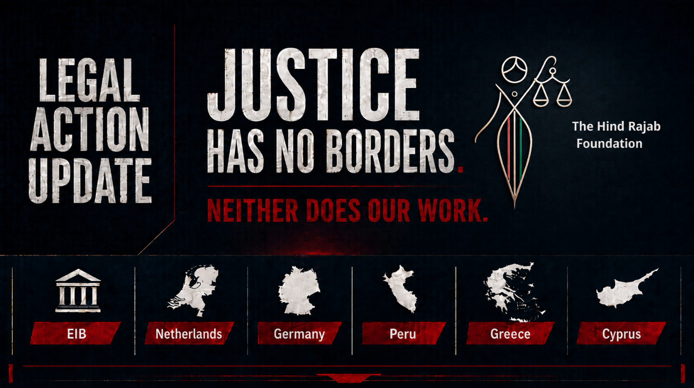

HRF has exposed due diligence failures at the European Investment Bank involving over €1 billion in settlement-linked investments.
It is pursuing legal action against Israeli soldiers in Amsterdam, Cyprus, and Peru for alleged crimes committed in Gaza.
In Greece, HRF-backed lawyers have triggered an investigation into Israeli Minister Israel Katz.
In Germany, HRF has filed a disciplinary complaint against a prosecutor accused of shielding a German-Israeli suspect.

Details below.

SUPPORT OUR WORK

After HRF Complaint: EIB Admits Due Diligence Failures Over €1 Billion in Investments Linked to Illegal Israeli Settlements

Following an HRF complaint, the European Investment Bank has admitted due diligence failures concerning more than €1 billion in investments linked to entities included in the UN database of companies involved in illegal Israeli settlements. This development places renewed scrutiny on European financial institutions and their responsibility not to contribute to or benefit from grave violations of international law.

Inside the Ruins of Justice: The Case Against Sergeant Shmuel Assouline in Amsterdam

HRF has sought the arrest of IDF Sergeant Shmuel Assouline in Amsterdam for alleged war crimes connected to the destruction of Gaza's Palace of Justice. The case concerns not only the physical destruction of a civilian judicial institution, but also the symbolic and material assault on the very infrastructure of justice in Gaza.

Germany: HRF Files Disciplinary Complaint Against Senior Federal Public Prosecutor

In Germany, HRF has filed a disciplinary complaint against a senior federal public prosecutor for shielding German citizen Shimon Zuckerman from genocide charges. The complaint challenges prosecutorial inaction and raises serious concerns about double standards when European citizens are implicated in atrocity crimes committed in Gaza.

Universal Jurisdiction in Action: Peru Investigates Israeli Soldier After HRF Complaint

In a landmark development, Peru has opened an investigation into an Israeli soldier from the Shaked Battalion following an HRF complaint alleging genocide and war crimes in Gaza. This case demonstrates the practical force of universal jurisdiction and confirms that accountability can advance far beyond the immediate geography of the crimes.

Greece Opens Investigation into Israeli Minister Israel Katz

A complaint filed in Greece by HRF and Greek lawyers has triggered an investigation into Israeli Minister Israel Katz over allegations of serious international crimes. This is another important step in ensuring that political office does not provide immunity for those suspected of involvement in grave violations of international law.

HRF Seeks Immediate Arrest of Israeli Soldier in Cyprus for Gaza Schools Destruction

HRF has filed a legal request in Cyprus seeking the immediate arrest of Israeli soldier Ori Narkis, alleging his involvement in war crimes and the destruction of civilian sites, including schools, in Gaza. The targeting or destruction of educational infrastructure is not only an attack on buildings, but on the future of an entire people.

These cases are part of HRF's broader strategy: to ensure that those responsible for international crimes in Palestine face legal consequences wherever they travel, invest, command, or seek protection.

Justice is no longer a distant promise. It is being pursued case by case, jurisdiction by jurisdiction, institution by institution.

We invite you to follow, share, and support this work.

