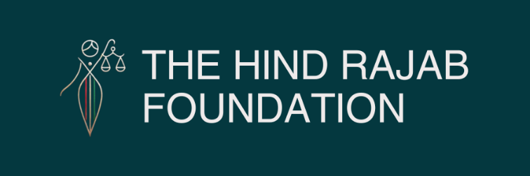

From Cancelled Travel to Expanding Cases: HRF Pressure on Israeli War Criminals Intensifies

Brussels – 14/04/2026

Legal pressure is now producing tangible effects across Europe. Following action by the Hind Rajab Foundation, Ofer Winter cancelled his trip to Italy to avoid the risk of arrest, marking a concrete form of accountability. At the same time, new proceedings have been initiated in Romania against Elyahu Nishli, expanding the legal front. In contrast, authorities in Lithuania have so far declined to investigate Sean Gor—despite his presence in the country as a student and his identification as a suspect in the killing of Hind Rajab—triggering both a formal appeal and a growing wave of protests demanding the consistent application of the law. Taken together, these developments indicate a clear trajectory: legal exposure is increasing, public pressure is intensifying, and the space for impunity is steadily shrinking across jurisdictions.

More details below.

SUPPORT OUR WORK

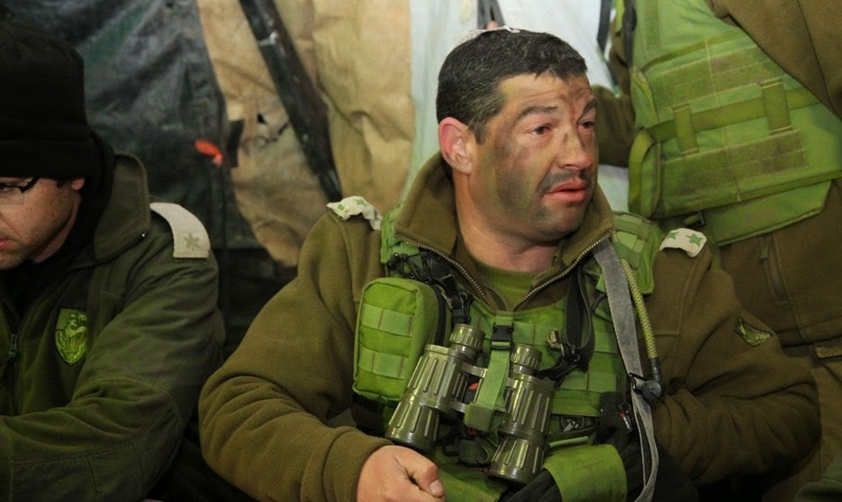

Ofer Winter Cancels Visit For Fears of Arrest
Following our legal action in Italy, Ofer Winter—a reserve commander, former Givati Brigade commander, associated with the 2014 Rafah "Black Friday" massacre, and now active as a genocide propagandist—cancelled his planned visit and did not enter the country out of fear of arrest. This is now confirmed.
This is a concrete and measurable win. When suspects begin to alter their movements to avoid jurisdictions, accountability has already begun.
But this is not the endpoint. Full accountability requires arrest and prosecution. That remains the objective.

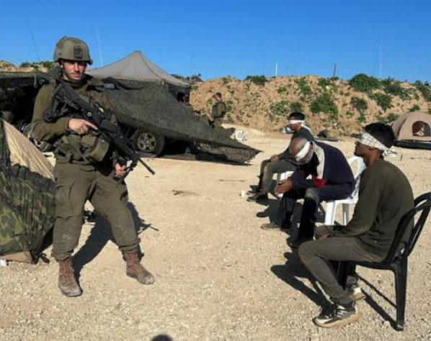

In Romania, the Hind Rajab Foundation has filed a criminal complaint against Israeli soldier Elyahu Nishli. The case is based on documented conduct during military operations in northern Gaza between November and December 2024.
Nishli served in the 97th Netzah Yehuda Battalion, a unit associated with repeated allegations of serious violations, including killings of detainees, torture, and degrading treatment.
The complaint outlines multiple alleged crimes under international law, including extensive destruction of civilian property, attacks against civilian objects, unlawful confinement, ill-treatment, torture, and outrages upon personal dignity.
Romania's jurisdiction is not abstract. Nishli has reportedly travelled repeatedly to the country and may hold Romanian nationality, reinforcing the legal obligation of authorities to act under applicable jurisdictional frameworks.



Appeal and Protest against Impunity of Vampire Empire Tanker in Lithuania
On 9 April 2026, Lithuanian authorities declined to open a pre-trial investigation into Israeli soldier Sean Gor, despite a detailed complaint submitted by the Hind Rajab Foundation. Gor is currently residing in Lithuania as a student in Kaunas, creating a clear jurisdictional link.
He has been identified as a member of the "Vampire Empire" company of the 52nd Armoured Battalion, 401st Armoured Brigade, and as one of 24 suspects linked to the killing of Hind Rajab.
The case of Hind Rajab remains central for us. The 5-year-old girl was killed on 29 January 2024 after her family's vehicle was subjected to sustained fire. An ambulance sent to rescue her was also targeted. Israeli armored units were operating in immediate proximity to the scene. The same unit has been linked to attacks on civilian infrastructure, including Palestine Square, UNRWA facilities, and Al-Shifa Hospital.
Lithuanian authorities cited insufficient direct evidence and limitations in exercising universal jurisdiction. The Hind Rajab Foundation has formally appealed, emphasizing that a pre-trial investigation is precisely the mechanism through which responsibility is established.
This refusal has triggered a public response. A growing wave of protests is emerging across Lithuania, led by students and supported by solidarity movements. Their demand is direct: apply the law. End impunity.
Taken together, these developments form a clear trajectory. Legal exposure is increasing. Cases are multiplying. Public pressure is intensifying.
The space for impunity is shrinking.

