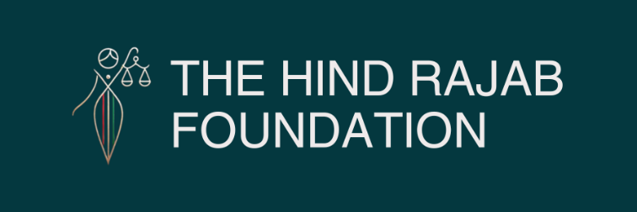

Brussels – 28/03/2026

HRF has filed a criminal complaint in Italy against Ofer Winter for war crimes committed in Gaza and for incitement to genocide. In recent videos, he not only doubles down on calls to destroy Gaza, but openly boasts about the Rafah "Black Friday" massacre and issues death threats against HRF's General Director. The question is now unavoidable: will Italy uphold the law and act, or allow him to speak in impunity on March 31?

More details below.

SUPPORT OUR WORK

He Boasts of Massacre. He Threatens Us. Will Italy Act?

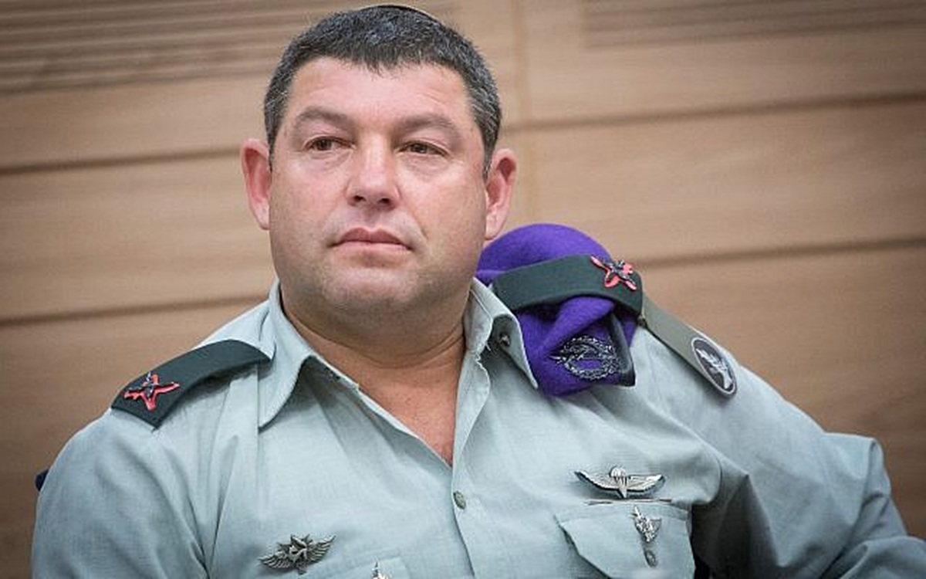

Dear friends,
Last Week, the Hind Rajab Foundation (HRF) filed a criminal complaint in Italy against former Israeli commander Ofer Winter.
This is not an abstract legal step. It is a direct confrontation with impunity.
Winter is not only accused of war crimes committed during the 2014 assault on Gaza. He is also, today, actively inciting the destruction of Gaza and the eradication of its people.
At the center of our complaint lies the Rafah "Black Friday" massacre of 1 August 2014.
Under Winter's command, the Hannibal Directive was activated. What followed was a sustained and indiscriminate assault on a densely populated civilian area: massive artillery fire, airstrikes, and attacks on civilians attempting to flee. Up to 200 civilians were killed in just three days. Hospitals, ambulances, a mosque, and a UN school were all targeted.
And now, more than a decade later, Ofer Winter does not deny these crimes.
He celebrates them.
In a recent video, published after our complaint was filed, he explicitly stated that he is proud of what happened in Rafah on that day.
At the same time, he has doubled down on his calls for the complete destruction of Gaza — advocating forced displacement, starvation, and the erasure of any distinction between civilians and combatants.
Even more, in a separate video, he issued direct death threats against our General Director, Dyab Abou Jahjah.
Let us be clear.
We will not be intimidated.
If anything, these statements confirm the necessity of our work. Impunity does not end crimes — it fuels them. It transforms perpetrators of yesterday into the inciters of today.
Ofer Winter is expected to travel to Italy next week, where he is scheduled to speak publicly on March 31.
This raises a fundamental question:
Will he be allowed to walk onto a public stage in Europe and speak in full impunity — after boasting about a massacre, calling for genocide, and issuing threats?
Or will the Italian authorities uphold the law?
Under international law, and under Italy's own legal obligations, authorities are required to investigate and prosecute individuals suspected of war crimes when they are present on their territory.
This is not about geopolitics.
It is about the rule of law.
And it is about whether Europe remains a safe haven for those who commit, justify, and promote international crimes.
We will continue to pursue this case with determination.
And we count on you — as always — to stand with us, to amplify this message, and to ensure that justice is not silenced.
In solidarity,
The Hind Rajab Foundation

