Today's headlines from Palestine and around the world. |  | View in browser



Today's headlines

The Israel lobby is melting down before our eyes
Philip Weiss
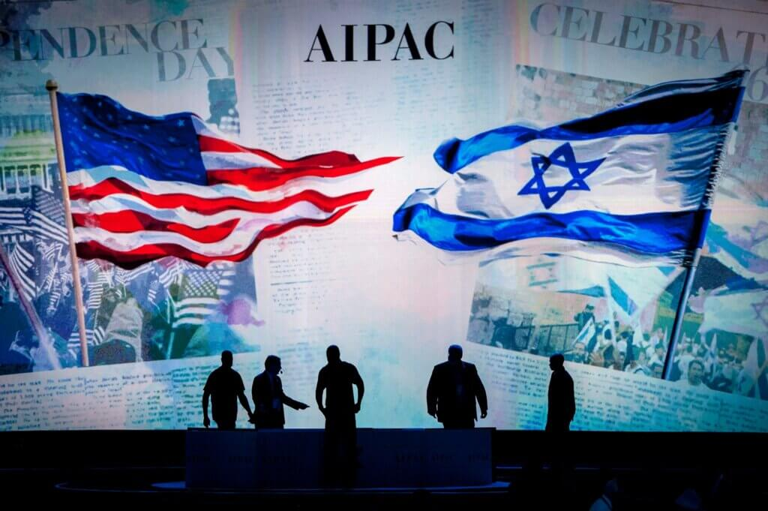
The American Jewish community is in open crisis over its support for Israel after two years of genocide in Gaza. A key issue in this crisis is a topic once considered too taboo to criticize: the Israel lobby.
Read more

Stop calling right-wing criticism of Israel ‘anti-Zionism’
Matt Seriff-Cullick

Recent comments by Tucker Carlson and Candace Owens have drawn more attention to right-wing critiques of U.S. support for Israel. However, it is a serious mistake for those on the left to see this anti-Israel criticism as “anti-Zionist.”

