

Dear Friend,
Bisan Owda films from Gaza with one cameraman.
Her videos have reached millions of people. Not because a network picked them up. Because she keeps filming, and Mondoweiss keeps publishing.
That's the model. Palestinian journalists telling the story. Independent media carrying it. Readers like you funding it.

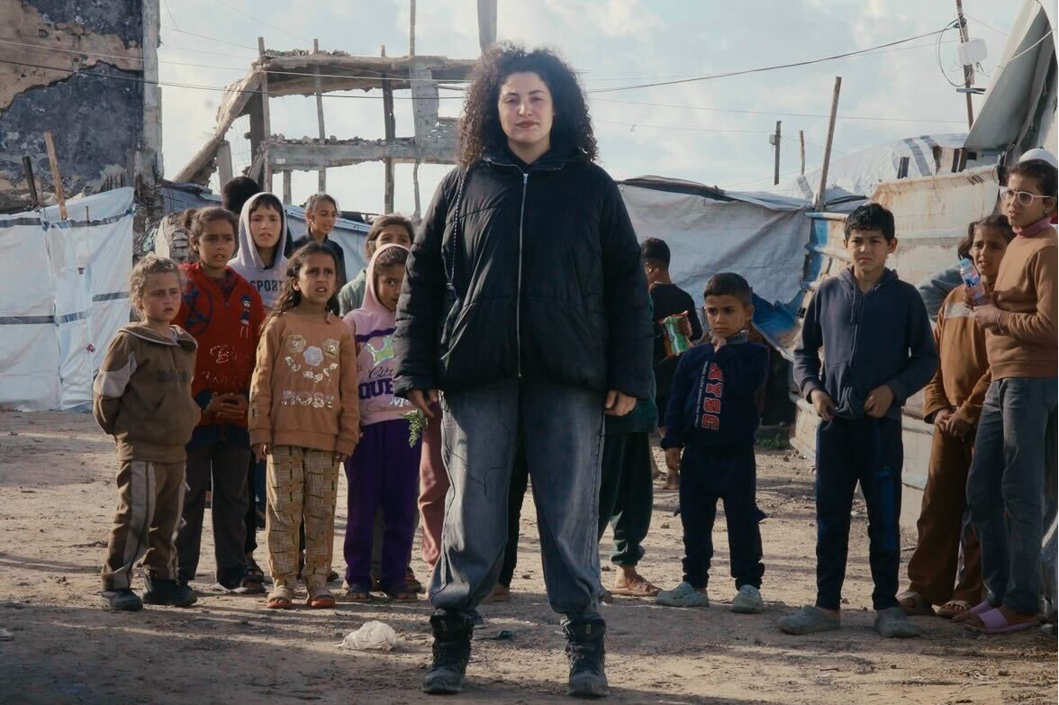

Corporate media had more than 2 years to tell this story of the genocide in Gaza honestly. They didn't.
Mondoweiss has spent 20 years refusing that frame. We publish Palestinian voices. We name what's happening. And we reach further than most people realize — 9 million accounts on Instagram alone in the last 90 days.

