Plus: Gaza's markets have food but no buyers and Lebanon's camps lose critical aid. | View in browser



Politicians confront genocide and democracy as elections loom in Palestine, Israel, and the U.S.

Jonathan Ofir reports on Naama Lazimi, the Israeli politician Haaretz crowned the left's rising star. In an attempt to appeal to liberal Israelis, Lazimi dropped Yair Golan's open calls for starvation in favor of a "political arrangement" that rules out a Palestinian state and a return to formal separation. Lazimi admits she wants no Palestinian state and equivocates on the Gaza genocide, but she still counts as the far left in Israel today.
A coalition of Hamas, Islamic Jihad, and rival Fatah currents is preparing to contest Palestinian elections announced for November, the first since 2006. Meanwhile, Israel has doubled the number of Palestinians in its prisons since October 7 and criminalized organized political life in the process. Qassam Muaddi examines whether any new legislative council could function under those conditions, let alone unite Gaza and the West Bank.
Qassam also profiles Muhammad Dahlan, the UAE-based Fatah dissident and longtime Hamas nemesis whose plan to "end Palestinian division" has quietly become the alliance's working platform. Backed by Gulf money and aligned with Trump's postwar plans for Gaza, Dahlan is positioning himself to reenter Palestinian politics through a proposal that promises unity without settling who actually governs.
In the U.S., the House passed a bill barring universities from boycotting Israel, with 33 Democrats who've received more than $9.4 million from AIPAC's Super PAC this cycle providing the margin of victory. Michael Arria also covers the Trump administration's quiet extension of its Iran deployment into 2027, even as 63% of Americans oppose the war, and U.S. strikes have killed civilians at a wedding for the fourth time.

🚨 Independent media in the United States is under attack like never before. This is especially true of media that covers the truth about Palestine. We need your support now. If you believe that a free press is essential to democracy and the struggle for freedom in Palestine, donate today.

 |  | David Reed, Publisher  Articles / Support our work today

📺 Watch: Why Are Democrats Attacking Hasan Piker?

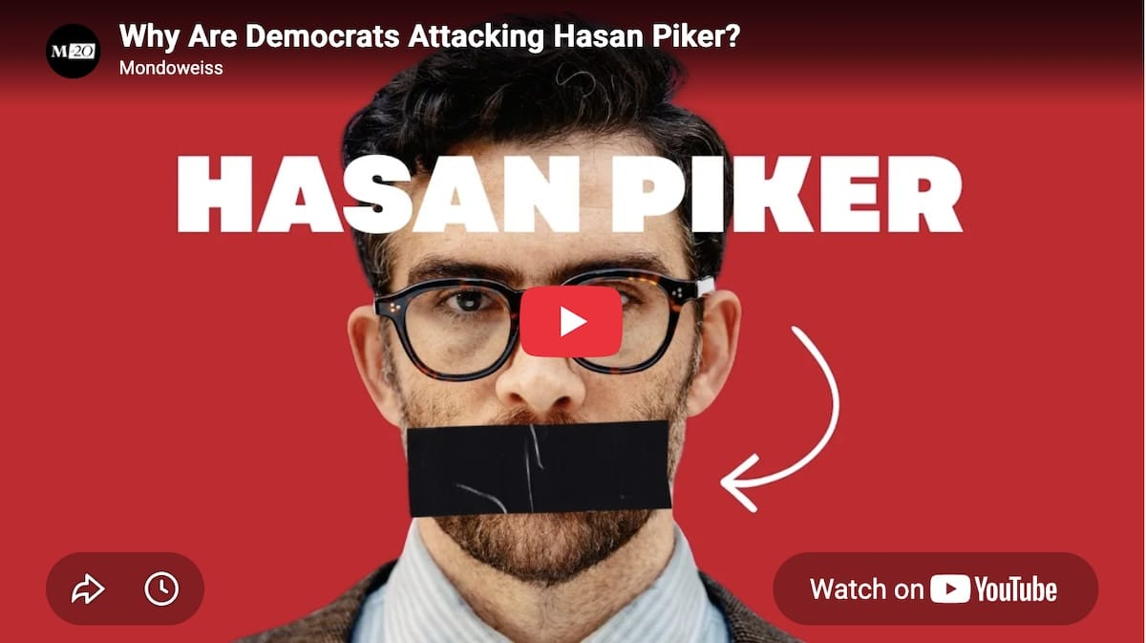

Subscribe to our YouTube channel!

🗳️ Palestinian, Israeli, and U.S. politics

Elections are approaching in Palestine, Israel, and the United States. The actions of the right-wing Netanyahu and Trump governments are driving potential political realignments.
READ MORE → After two decades, Palestinians prepare to vote for a new political leadership. But will it change anything? — Qassam Muaddi
READ MORE → This UAE-backed Fatah dissident is allying with Hamas and pushing a proposal to change Palestinian politics — Qassam Muaddi
READ MORE → Meet the new 'superstar' of the Israeli left, who is so progressive she only supports apartheid — Jonathan Ofir
READ MORE → The Shift: House passes bill blocking schools from boycotting Israel — Michael Arria

🇵🇸 Palestine and the region

Gaza's markets have goods again, but no one can afford them. Lebanon's refugee camps are being cut off from aid. Iran and the U.S. keep trading strikes while Trump refuses to call it a war.
READ MORE → Food has returned to Gaza's markets, but most people still can't afford to eat — Tareq S. Hajjaj
READ MORE → 'They destroy, we build': Gazans rebuild their homes out of mud and rubble — Tareq S. Hajjaj
READ MORE → What do you do when you can't hear the bombs? Being deaf during the Gaza genocide. — Jumana Mughari
READ MORE → Gaza's archaeological heritage was destroyed in Israel's genocide. These volunteers are trying to salvage it from the rubble. — Tareq S. Hajjaj
READ MORE → Palestine Letter: Reporting on one crisis after another — Tareq S. Hajjaj
READ MORE → 'We are not beggars': UNRWA cuts off aid to six Palestinian refugee camps in northern Lebanon — Alaa Serhal
READ MORE → Palestinian Christians are disappearing. Warnings are not enough. — Sami Mshasha
READ MORE → What the latest flare-up between the U.S and Iran means — Mitchell Plitnick

