Uncertainty is the rule of the day as Trump flails around the world. | View in browser



Bored of peace, Trump seems set on dragging us into war on Iran

This week Donald Trump launched his "Board of Peace." This absurd exercise is a blatant attempt to further undermine the prevailing international system and, at the same time, lay the foundation to capture massive amounts of money that will have to be spent to rebuild Gaza. It's pure corruption; so bad that many nations and international figures kept their distance. We have several items about it below. The other major story is the military build-up Trump has committed in the Middle East aimed at Iran. Are we going to attack Iran? Who knows. Constant uncertainty is the rule of the day. We also lost Jesse Jackson this week. Michael Arria spoke to James Zogby about his legacy.

 |  | David Reed, Publisher  Articles / Donate today

📹 Video

This is how Israel uses food to colonize Palestine and erase Palestinian culture and identity.

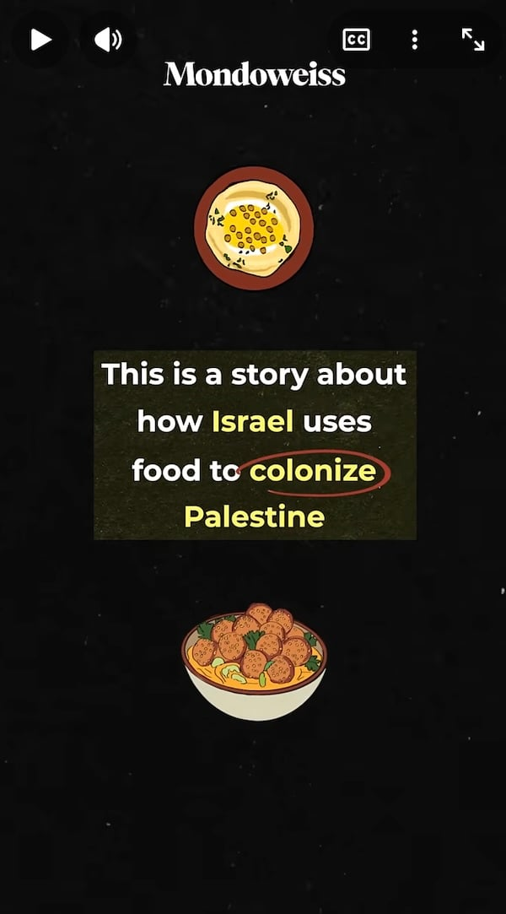

🇮🇱 Israel makes Palestinian life unlivable

In Gaza, Noor Alyacoubi brings us the heartbreaking story of a young women whose rare skin disease requires a strict daily routine of constant moisturization, careful hygiene, and a humid, climate-controlled environment. The genocide in Gaza has made this impossible. Qassam Muaddi reports on the Israeli plans to displace tens of thousands of Palestinian refugees in Qalandia refugee camp and Kufr Aqab.
READ MORE → How Israel's genocide in Gaza has made it nearly impossible for this Palestinian teenager to manage her chronic illness
READ MORE → The Palestinians stuck in the no-man's-land of Jerusalem and the Israeli settlement plan to expel them

☮️ Bored of Peace

Donald Trump convened the first meeting of his so-called "Board of Peace" this week. Despite much fanfare, key nations refused to join, the Pope turned him down, and he struggled to even stay awake during the plodding and absurd speeches. Our writers covered it extensively.
READ MORE → Palestinian resistance and the trap of Trump's 'Board of Peace' – Abdaljawad Omar
READ MORE → Trump's 'Board of Peace' aims to turn Gaza into a playground for investors – Qassam Muaddi
READ MORE → Trump's 'Board of Peace' reveals grim future the U.S. and Israel have planned for Gaza – Mitchell Plitnick
READ MORE → Pope Leo rejects Trump invitation to join Gaza 'Board of Peace' – Jeff Wright

✊ Communities take action

People continue to fight back against the Israeli occupation. This week the new comptroller in New York City announced he would resume investments in Israel Bonds, and people are organizing to stop it. Activists successfully pressured the Brooklyn Navy Yard Development Corporation to end the lease of a company that supplied drone weaponry to Israel. and in Missouri, a bill there to adopt the IHRA definition of antisemitism would limit first amendment speech in schools.
READ MORE → Can activists stop NYC from reinvesting in Israel Bonds? – Michael Arria
READ MORE → Power & Pushback: Brooklyn Navy Yard evicts drone maker amid pressure campaign – Michael Arria
READ MORE → Organizers fight back as Missouri moves to crack down on Israel-related speech in schools – Marianne Dhenin

🇮🇷 We're being dragged into war with Iran

Chicken hawks in the United States are once again driving us toward war in the Middle East. The long-dreamed about war with Iran may be launched soon, as the Trump administration has moved the largest build-up of troops to the region since the war on Iraq. We spoke to Sina Toossi about the state of things, looked at the coverage from quisling media outlets, and heard about the wave of protests in Iran from someone who witnessed them.
READ MORE → Trump appears to be gearing up to attack Iran. How close are we to war? – Michael Arria interviews Sina Toossi
READ MORE → Netanyahu and Israel are provoking the U.S. into attacking Iran — and the media continues to ignore it – James North
READ MORE → The night the protests in Iran were co-opted by outside forces – Nargol Aran

🙏 Jesse Jackson, ¡Presente!

We lost Jesse Jackson this week. Friend-of-the-site James Zogby spoke to Michael Arria about the legacy Jackson left with the Arab-American community.
READ MORE → How Jesse Jackson helped bring Arab-Americans into the political process – Michael Arria

