

Israel is pushing Palestinian hospitals in Gaza and the West Bank toward collapse

New York goes to the polls on June 23, and Palestine has already shaped the field. Zohran Mamdani's mayoral victory over Andrew Cuomo last year upended the assumption that support for Palestinian rights was a political liability. In the weeks since, from the Park Slope Food Coop's boycott vote to the charged congressional primary between Brad Lander and incumbent Dan Goldman, the issue has continued to drive outcomes that few in the political establishment anticipated. Michael Arria speaks with political consultant Peter Feld about what the shifting terrain means for the upcoming primaries, and what may be coming next.
In late April, a federal judge in São Paulo sentenced Zé Maria to two years in open prison for a speech in which he called for the liberation of Palestine. Zé Maria is a 69-year-old metalworker and union activist who was imprisoned under Brazil's military dictatorship alongside Lula. The lawsuit was filed by the Israeli Confederation of Brazil using the IHRA definition of antisemitism, and his case is not isolated. Blanca Missé documents how the IHRA definition is being deployed in a coordinated offensive across Latin America to criminalize Palestine solidarity, with its primary targets drawn from the backbone of the region's social movements.
Israel has been withholding Palestinian customs revenues indefinitely, and the effect on the West Bank's public health system is now showing up in hospitals. Public hospitals have slashed workers' salaries, cut their hours, and left patients navigating a system running on interns and labs operating at half-capacity. Healthcare workers have gone on strike. Qassam Muaddi reports from inside the Ramallah Medical Complex on what Israel's financial siege is doing to Palestinian healthcare in the West Bank.
On May 31, the director of al-Aqsa Martyrs' Hospital in Deir al-Balah announced that the facility was once again on the verge of closing after its fourth generator failed. Half a million people depend on it for medical care. Gaza's electrical grid was destroyed in October 2023, and the generators that replaced it have been running continuously for over three years. Health officials say Israel has calibrated its restrictions on fuel and supplies deliberately, allowing just enough in to prevent total collapse while ensuring hospitals cannot recover. Tareq S. Hajjaj reports on what staff and officials describe as a deliberate effort to destroy Gaza's healthcare system through the calibrated denial of fuel and supplies.
Our Summer Fundraising Campaign ends June 15, and we need to raise $80,000 to close out our fiscal year. A $10,000 donor match is doubling every gift right now, and we need 100 new monthly donors at $15 or more. Please donate and join the 15 readers who've already signed up this month.

 |  | David Reed, Publisher  Articles / Support our work today

📺 WATCH: AIPAC smear campaigns aren't working anymore

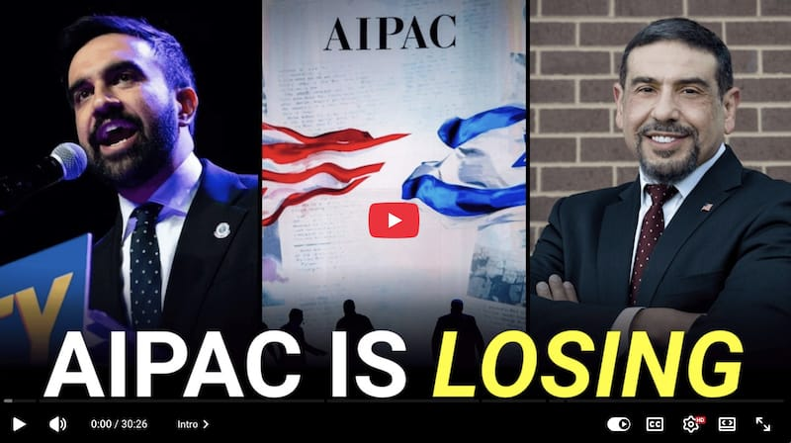

🇵🇸 West Bank

This week, Israeli soldiers shot and killed a seven-month-old infant in Hebron. A new digital registry is imposing Israeli administrative sovereignty over 60 percent of the territory, structuring Palestinian land claims so that they are designed to fail from the start.
READ MORE → Israeli soldiers shot and killed this Palestinian baby in the West Bank — Qassam Muaddi
READ MORE → Digitally annexing the West Bank: Israel moves its theft of Palestinian land online — Qassam Muaddi

🇺🇸 United States

A surgeon who volunteered in Gaza won a congressional primary in New Jersey, pro-Israel smear campaigns are failing where they once reliably ended careers, and a debate has opened inside the Trump administration over whether Israel's war aims will determine the outcome of negotiations with Iran.
READ MORE → One result of the sea change in U.S. politics regarding Palestine: pro-Israel smear campaigns no longer work — Michael Arria
READ MORE → The Shift: Doctor who served in Gaza wins New Jersey primary — Michael Arria
READ MORE → Will Trump sideline Israel in order to make a deal with Iran? — Mitchell Plitnick

📉 Divestment

Maryland's state pension system has divested 85 percent of its Israeli bond holdings amid sustained organizing, while advocates in New York are pressing the state's Common Retirement Fund to follow on its $367 million stake.
READ MORE → Power & Pushback: Maryland pension system divests 85% of Israeli Bond holdings amid pressure campaign — Michael Arria
READ MORE → New York State must divest from Israel Bonds — JVP Rochester

🚨 Repression and resistance

In Copenhagen, activists who protested for an academic boycott now face charges that could bring up to six years in prison. At the New School in New York, students went on offense, sanctioning the campus Hillel chapter for its documented ties to Israeli war crimes.
READ MORE → The University of Copenhagen is complicit in Israel's genocide in Gaza and is now trying to criminalize those who protest it — Aleksandra Milanovic
READ MORE → Here is why we sanctioned Hillel at the New School and why students everywhere should follow our lead — Ryder Glickman


Your support is critical to our reporting.
We need to raise $80,000 during our Summer Fundraising Campaign. Right now, your donation will be matched!
Become a donor today!

Wait! Before you go...

Mondoweiss is an independent, reader-funded publication. We publish stories and analysis about the struggle for freedom in Palestine that you will not find in corporate media. Our growing team relies on your support. Here are some ways you can help...
💸 Join our supporters and become a Mondoweiss donor today.
🗣️ Share Mondoweiss articles on X, Facebook, Instagram, or any other social media platform you are active on.
📺 Subscribe to our YouTube channel and help us reach 100,000 subscribers!
🛍️ Shop our online store! We offer a selection of union-printed t-shirts and totes, as well as several fascinating books. We also ship internationally.
📨 Forward this email to a friend.
🎧 Subscribe to our podcast anywhere you listen.

