

After 78 years, the Palestinian Nakba continues

May 15 is Nakba Day and, this year, the 78th anniversary of the dispossession that created the Palestinian refugee crisis and established the political conditions that define the region to this day. It is clearer than ever before that there is no separating 1948 from the present. The Nakba is a colonial enterprise that continues, not an event of the past. This week's reporting at Mondoweiss reflects that continuity.
Najib Antoine Jabre's piece, published today, covers a dimension of the Nakba that rarely receives attention. When Palestinians were expelled in 1948, they not only lost their homes and land. They lost access to bank accounts, business assets, and accumulated savings. This financial wealth was absorbed by the Israeli state and never returned. Jabre estimates the total value of that stolen property at over $100 billion. It is a striking piece of research that reframes what reparations and the Right of Return would actually require. Salman Abu Sitta, one of the most important living Palestinian voices on the Nakba, published a forensic account, drawing on Eyal Weizman's new book, of what Zionist settlers did to his family's village and what they built on the ruins. If you only have time to read a few things, make it these two articles.
In the West Bank, Qassam Muaddi reports on a $270 million Israeli-only roads project that is among the Netanyahu government's most explicit moves yet toward de facto annexation. It is infrastructure that physically separates Palestinian communities while binding the territory more tightly to Israel. A second piece from Muaddi documents how Israeli settlers are systematically attacking Palestinian water sources across the West Bank, forcing communities off land they have farmed for generations. Muaddi also analyzes how Gaza has faded from the political foreground as the U.S. and Israel have become consumed by Lebanon and Iran, with no resolution in sight and no pressure on Israel to provide one.
The humanitarian situation in Gaza continues to deteriorate and should command far more international attention than it is receiving. Tareq Hajjaj reports on a rodent infestation that has produced more than 70,000 infections this year. This public health crisis was caused directly by Israel's genocidal destruction of the environment throughout the territory. Health officials now consider a plague outbreak a real possibility. Dr. Salman Khan, an infectious disease specialist who completed a medical mission in Gaza in February, writes from a clinical perspective about how the destruction of hospitals and the siege have created conditions in which treatable infections become fatal. Rami Rmeileh's piece examines how the psychological framework of "moral injury" is being applied to Israeli soldiers returning from Gaza, turning the guilt of perpetrators into a medical condition, and in doing so, shifting attention from Palestinian victims to Israeli participants.
This is all pretty heavy, but at least Keir Starmer is having a terrible week.
Until next week,

 |  | David Reed, Publisher  Articles / Support our work today

📺 Video: What is the Palestinian Nakba (2024)

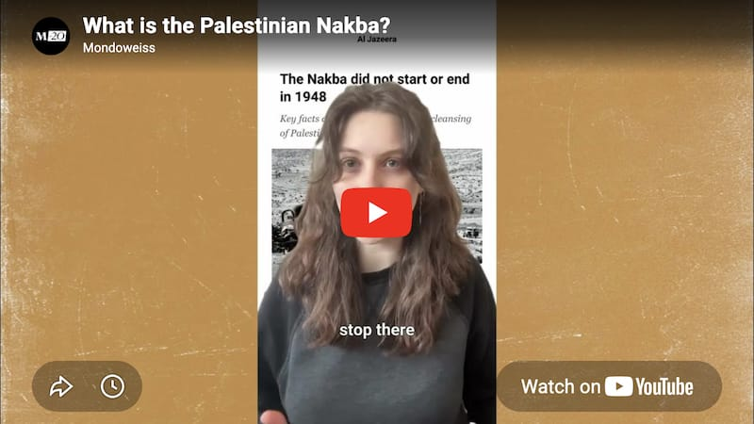

🗝️ Nakba

As Palestinians mark 78 years since the Nakba this week, two document what was taken and never returned.
READ MORE → Israel used the Nakba not only to steal land, but Palestinians' financial wealth too – Najib Antoine Jabre
READ MORE → A forensic account of the horrors my family experienced during the Nakba – Salman Abu Sitta

🇺🇸 United States

Gaza is shifting American politics. A combat surgeon who volunteered there during the genocide is now one of the frontrunners in a New Jersey congressional race.
READ MORE → How Dr. Adam Hamawy's experience as a surgeon in Gaza inspired him to run for Congress — Michael Arria

🇵🇸 Gaza and the West Bank

Israel's assault on Palestinian life is advancing on multiple fronts. In the West Bank, settlers are cutting off water sources and the Netanyahu government is expanding roads Palestinians cannot use. In Gaza, the genocide continues with no political resolution in sight, and the conditions Israel created are bringing cascading public health crises.
READ MORE → New $270 million Israeli-only roads project in the West Bank is Netanyahu's latest bid to impose de facto annexation — Qassam Muaddi
READ MORE → Rodent infestation caused by Israel's destruction of Gaza is now creating a public health catastrophe — Tareq Hajjaj
READ MORE → The catastrophic impasse in Gaza is the new status quo — Qassam Muaddi
READ MORE → How Israel is weaponizing infectious diseases in Gaza — Salman Khan
READ MORE → How modern psychology is turning a genocidal army into a 'morally injured' one — Rami Rmeileh
READ MORE → How Israeli settlers are weaponizing water against Palestinians in the West Bank — Qassam Muaddi

🌍 Iran, Lebanon, and the Gulf

The wars the U.S. and Israel launched across the region are not over, and their costs are still mounting. Trump is looking for a way out of Iran. The Gulf states that enabled the project are discovering what they are worth to Washington. And in South Lebanon, Israel is killing rescue workers the same way it kills them in Gaza.
READ MORE → Trump knows he lost the Iran war, and is now desperate to find a way out — Mitchell Plitnick
READ MORE → Fatal Friendships: Gulf monarchies and the price of American patronage — Ziyad Motala
READ MORE → As in Gaza, Israel is targeting rescue workers in South Lebanon, killing more than 100 since March — Alaa Serhal

