

Dear Mondoweiss reader,
Last week, our Gaza correspondent Tareq Hajjaj gathered testimonies from the families of Gaza's disappeared — those whose loved ones went missing during the genocide and have not been seen since. One family recognized their elderly mother and her daughter in a selfie taken by Israeli soldiers in the back of a military vehicle, which surfaced on social media a year after it was taken. The family still doesn't know if the women are alive.
Over two years on, at least 8,100 people are still missing in Gaza, and more are disappearing. But you wouldn't know it from reading the mainstream media.
As Mondoweiss Palestine Editorial Director I have the responsibility of making tough decisions, not just about what stories to cover, but about which ones we've had to leave untold due to lack of resources.
You can help! Make a donation today to our summer campaign and ensure we can provide a platform for Palestinian stories that deserve to be told. We still need to raise $65,000 to reach our goal. Any amount helps.

Fund Palestinian stories

The biggest impact you can make is by setting up a monthly gift. It allows us to write pieces that require time and dedication from our writers.

Become a monthly donor

Also last month, Palestine Staff Writer Qassam Muaddi, went inside the Palestine Medical Complex in Ramallah to document the collapse of the Palestinian public healthcare system. For months, healthcare workers have been on strike to protest salary cuts exacerbated by Israel's withholding of Palestinian customs revenue since October 2023. Qassam found patients navigating empty corridors, a system running on interns, and labs operating at half-capacity.
These two stories — one from Gaza, the other from the West Bank — each show you fragments of the same reality: the systematic destruction of Palestinian life.
With the fraction of the budget other newsrooms have, we have to choose what parts of the Palestinian experience to leave out. Your contribution makes a difference, it allows us to tell the whole story with its complexities, providing you with a comprehensive understanding other outlets simply can't provide.
At the Mondoweiss Palestine Bureau we have a responsibility. Our reporters are bearing witness. Please bear witness with us.

Match my gift

Thank you,
Faris Giacaman

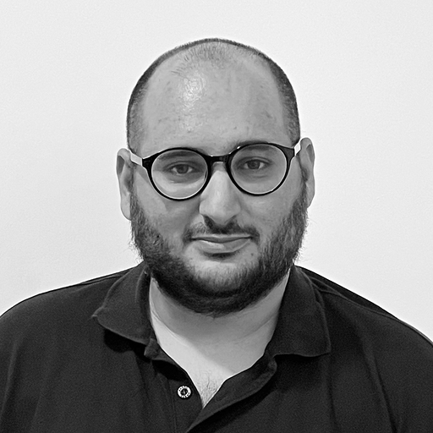 |  | Faris Giacaman, Palestine Editorial Director  Mondoweiss

