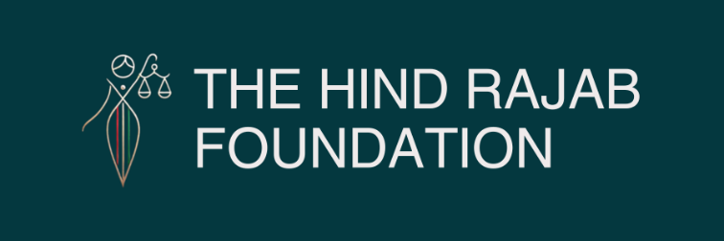

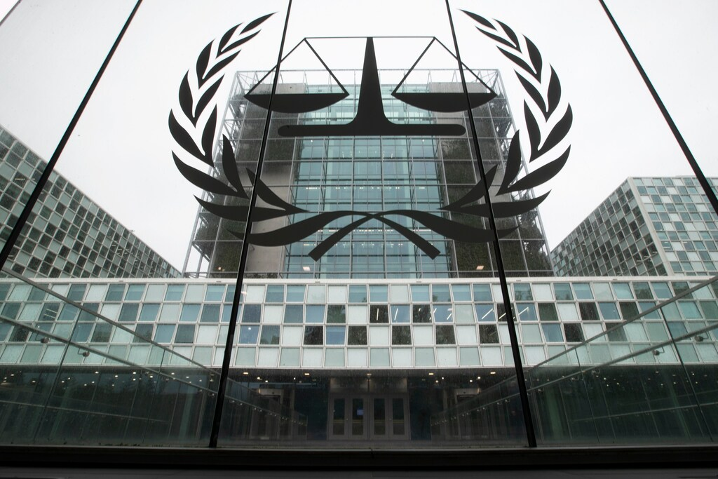

Following our urgent complaint, Belgian authorities arrested two Israeli soldiers at Tomorrowland over credible war crimes in Gaza. After investigation and interrogation, the case was referred to the ICC.

This marks a historic step—but not enough. Belgium should have detained and prosecuted them. Releasing suspects risks reinforcing impunity.

We call on the ICC to act without delay. Justice must go further—and we will not stop.
Read the full press release below.

SUPPORT OUR WORK

Date: 30 July 2025
​
Brussels — The Hind Rajab Foundation acknowledges the communication from the Belgian Federal Prosecutor confirming that a criminal investigation was opened following our urgent complaint of 18 July 2025 concerning credible war crimes committed in Gaza by Israeli military personnel.
The suspects, both actively serving in the Israeli armed forces, were formally identified, arrested and interrogated by Belgian authorities at the Tomorrowland festival in Boom. This unprecedented act was only possible because the allegations were deemed serious enough to warrant direct judicial action. A recognition that the evidence presented is compelling and falls within the scope of international criminal law.
We note with cautious encouragement that the Belgian Federal Prosecutor has decided to refer the case to the International Criminal Court (ICC) in The Hague, invoking Belgium's cooperation framework with the ICC. This referral confirms that the matter has reached the highest level of international legal attention.
However, we believe Belgium should have gone further. In our view, the suspects should not only have been arrested, but also detained and either prosecuted in Belgium or extradited to the ICC. Belgium has the legal basis and responsibility to do so. The current interpretation of its jurisdiction is, in our opinion, unnecessarily limited.
Releasing individuals credibly accused of war crimes and crimes against humanity not only undermines public trust in justice, but risks reinforcing a sense of impunity and may enable those individuals to commit further atrocities.
This referral is not a conclusion. It is a strategic pivot to the international level. Eventhough legally permissible, it is also a reflection of diplomatic caution at a time when genocide is ongoing. In our view, political considerations should never outweigh the imperatives of justice.
We now urge the ICC to act without delay and issue arrest warrants against the suspects. Every day of inaction by international institutions is a day of continued suffering and unaccountability.
Let it be clear: this case sets a legal and moral precedent. Israeli military personnel, no matter where they travel, are not beyond the reach of justice. We will continue to identify and file criminal complaints against any war crimes suspects entering Belgian territory, especially those with dual nationality or clear links to Belgium. We will also continue working with legal networks across Europe to ensure that universal jurisdiction is effectively applied and not gradually eroded.

