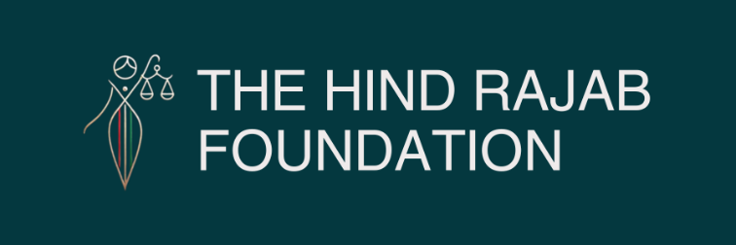



BREAKING: In a historic move, Belgian police arrested and interrogated two Israeli soldiers at Tomorrowland following a legal complaint by the Hind Rajab Foundation and GLAN, citing credible allegations of war crimes in Gaza. The suspects were later released, but Belgium has officially opened a criminal investigation — marking a major breakthrough in the application of universal jurisdiction.
This is more than an isolated action. It sets a powerful precedent:
🔹 Western soil is no longer guaranteed impunity
🔹 Universal jurisdiction is becoming a reality
🔹 Governments can no longer ignore credible evidence of atrocity crimes

Read the full press release below.

SUPPORT OUR WORK

Brussels – 21 July 2025
In what may become a turning point in the global pursuit of accountability, Belgian federal police have arrested and interrogated two Israeli soldiers credibly accused of war crimes in Gaza. The action came in response to an urgent legal complaint filed by the Hind Rajab Foundation and the Global Legal Action Network (GLAN) earlier this week.
The suspects were identified and arrested with a clear show of force at the Tomorrowland festival in Boom. After being taken into custody, they were formally interrogated and released. The Belgian Federal Prosecutor's Office has confirmed that a criminal investigation is now underway.
This development is a significant step forward. It signals that Belgium has recognized its jurisdiction under international law and is treating the allegations with the seriousness they deserve. At a time when far too many governments remain silent, this action sends a clear message: credible evidence of international crimes must be met with legal response — not political indifference.
We do not claim that justice has been served — not yet. But we believe something important has begun. For the first time in Europe, Israeli suspects linked to crimes in Gaza have been subjected to formal arrest and questioning. This would not have been possible without the strength of the law and the will to apply it.
To the victims and survivors in Gaza: we see you, we hear you, and we carry your demands for justice forward.
To those who believed impunity was permanent: this moment shows that it is not.
And to states watching around the world: universal jurisdiction is not just a principle — it is an obligation.
The Hind Rajab Foundation and GLAN welcome this breakthrough with determination and humility. We will continue to support the ongoing proceedings and call on Belgian authorities to pursue the investigation fully and independently. Justice must not stop here — and we are committed to seeing it through.

