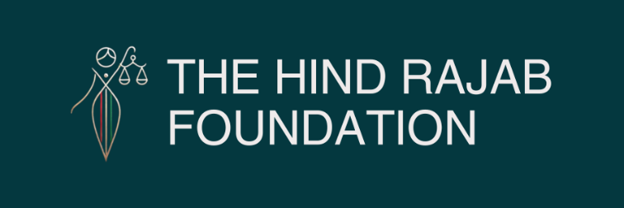

Brussels – 11/02/2026
The Hind Rajab Foundation has supported a landmark private prosecution in Australia against Israeli President Isaac Herzog on charges including genocide and crimes against humanity.
In parallel, HRF has filed a legal complaint in the United States against Israeli soldier Adi Karni.
The U.S. complaint invokes federal statutes criminalising war crimes and genocide.
More details below.

SUPPORT OUR WORK

Australia: Private Prosecution Filed Against Herzog

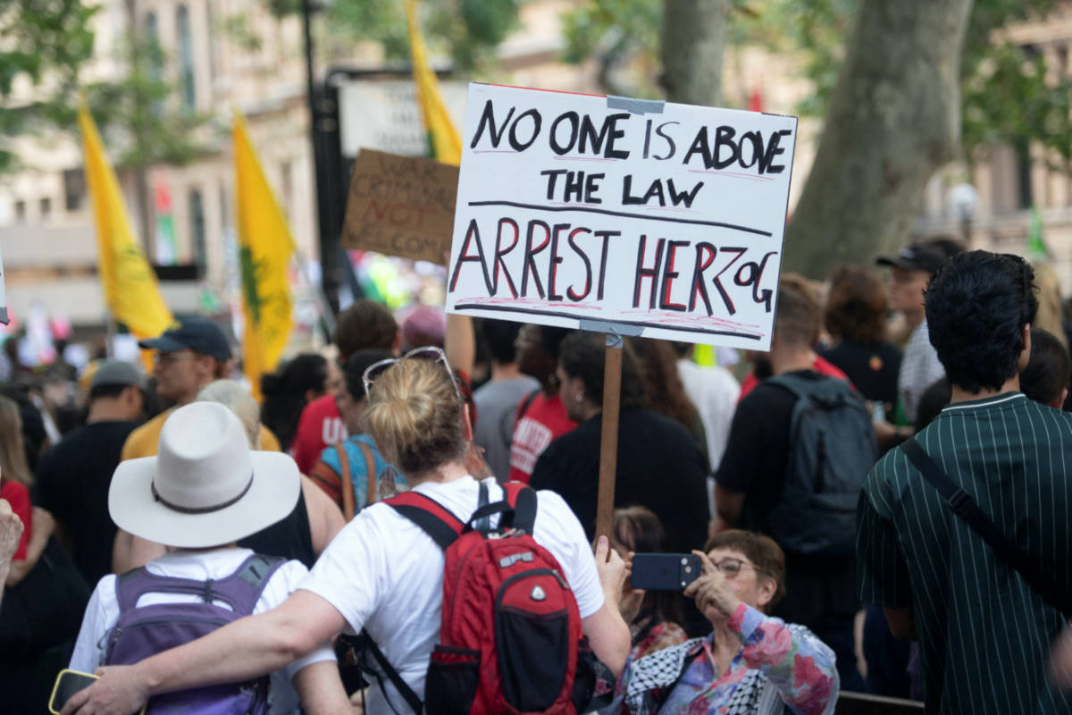

Sydney/ Australia
A landmark private prosecution has commenced in Australia against Israeli President Isaac Herzog, following a joint complaint submitted by the Hind Rajab Foundation (HRF), the Jewish Council of Australia, and the Australian National Imams Council (ANIC).
Lawyers representing Melbourne academic Tasnim Sammak have filed a charge sheet in the Magistrates' Court of Victoria alleging eight serious offences, including genocide and crimes against humanity, under Australian federal law.
The genocide charge is brought under Section 268.5 of the Commonwealth Criminal Code, which grants extended geographical jurisdiction over international crimes. The filing alleges that President Herzog, through acts and public statements, aided and abetted the deliberate infliction of conditions of life calculated to bring about the destruction of the Palestinian people in Gaza.
HRF has announced that it will seek leave to intervene as amicus curiae should proceedings advance.
"International criminal law exists precisely to address situations where state power is used to destroy a protected population. If domestic courts have jurisdiction, they must act. Immunity cannot become impunity," said Dyab Abou Jahjah, General Director of HRF.
This case represents a significant step in activating domestic courts where international mechanisms remain slow or constrained.

United States: Legal Complaint Filed Against Adi Karni

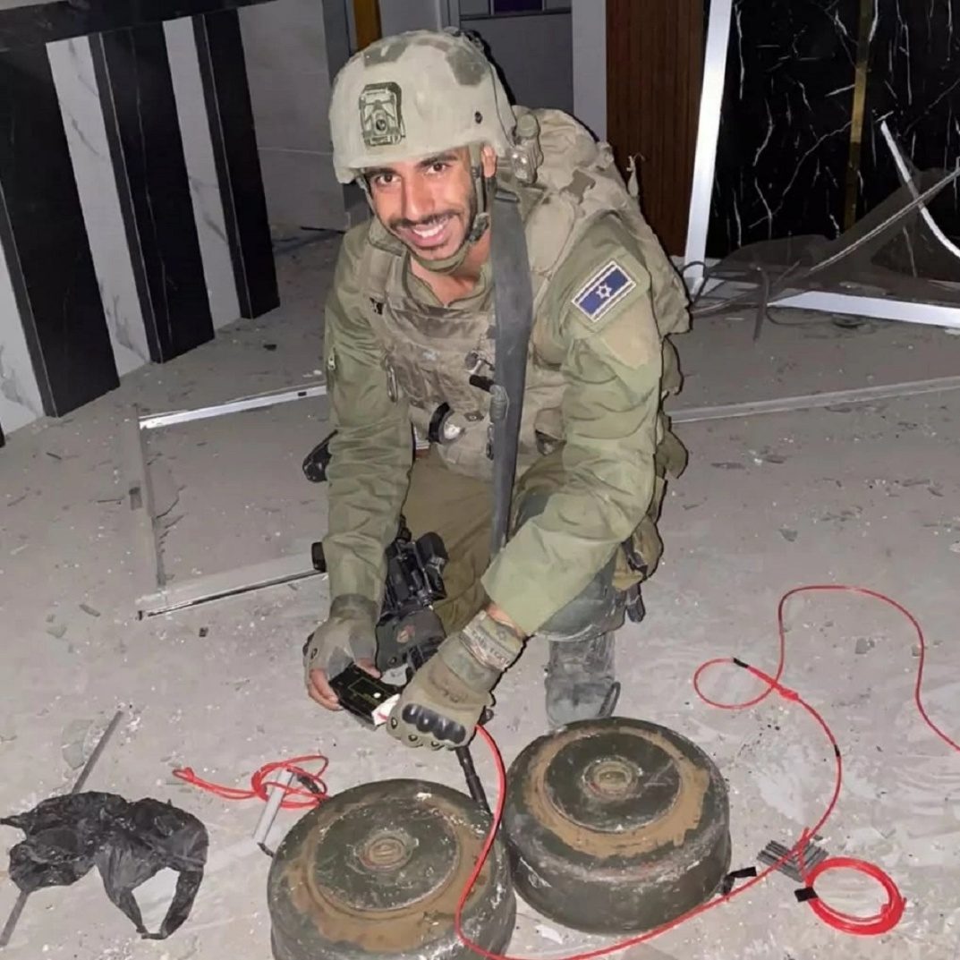

New York / United States
In parallel, HRF has filed a legal complaint in the United States against Adi Karni, a former sergeant in the 603rd Combat Engineering Battalion, currently present in the U.S. and recently invited to speak at Boston University.
The filing is grounded in U.S. federal statutes, including:
18 U.S.C. §2441 (War Crimes Act)
18 U.S.C. §1091 (Genocide Statute)
HRF's investigative report documents Karni's alleged participation in the destruction of civilian and religious structures in Gaza and highlights public statements denying the existence of civilians in Gaza — rhetoric legally relevant to establishing genocidal intent.
Notably, HRF has already filed against Karni in Peru, where a criminal investigation is open for genocidal crimes. Additional filings have been made in other jurisdictions as part of a coordinated legal strategy.
Karni's current presence in the United States activates U.S. jurisdiction.
"Presence triggers responsibility. When individuals credibly implicated in international crimes are found on U.S. soil, investigation is not discretionary — it is required," said Jake Romm, HRF's U.S. representative.

