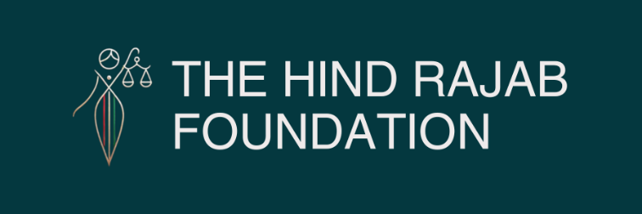

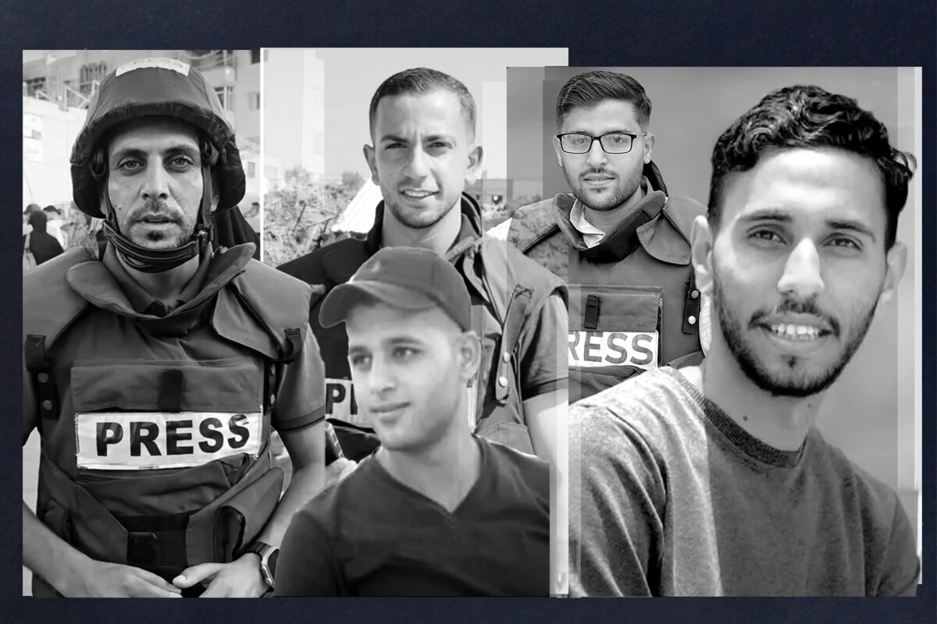

The Hind Rajab Foundation, together with the Palestinian Center for Human Rights, has filed a powerful case at the International Criminal Court naming the Israeli military and political figures behind the assassination of Al Jazeera journalist Anas Al-Sharif and his colleagues. This unprecedented complaint identifies top commanders—Lt.-Gen. Eyal Zamir, Maj.-Gen. Tomer Bar, Maj.-Gen. Yaniv Asor, Brig.-Gen. Yossi Sariel, the Palmachim Airbase Commander, the "Black Snake" Squadron Commander, and Col. Avichay Adraee—and demands their immediate arrest. It also calls for expanding Benjamin Netanyahu's arrest warrant to include crimes against journalists, framing these killings as part of a systematic effort to erase witnesses and silence the truth from Gaza.

Read the full press release below.

SUPPORT OUR WORK

By any measure, Anas Al-Sharif should still be alive.
On the morning of 10 August 2025, the 28-year-old Al Jazeera Arabic correspondent was doing what he had done since the first days of the Gaza onslaught—reporting from the frontlines, armed only with a camera and a press vest. Outside the main gate of Al Shifa Hospital, in one of the last corners of northern Gaza where journalists could still work, Al-Sharif was filing footage of bombardments that shook the streets around him. Moments later, a missile struck the tent where he and his colleagues were sheltering.
Seven people died instantly. Among them: Mohammed Qreiqeh, Ibrahim Zaher, Mohammed Noufal, and Moamen Aliwa—four Al Jazeera journalists who, like Al-Sharif, had refused to stop documenting the Genocide. Mohammed Al-Khaldi, also a journalist who worked for Sahat Media Platform, and Saad Jundiya, a Palestinian civilian who happened to be present in the scene at the time of attack were also killed.
The Israeli military would later admit the strike was deliberate. Their justification? The same recycled accusation used in killing over 220 journalists since October 2023: that the victims were "terrorists in press vests."
For the Hind Rajab Foundation (HRF) and the Palestinian Center for Human Rights (PCHR), this was not just another tragedy in a long war on the press. This was a clear-cut criminal act—a war crime and part of a broader genocidal campaign—and it demanded a direct, targeted legal response.

A Joint Case to The Hague

The new Article 15 Communication to the International Criminal Court was filed jointly by HRF and PCHR. While HRF focused its investigation on the chain of command and operational decisions that led to Al-Sharif's killing, PCHR brought to the case its meticulous documentation of the other Al Jazeera journalists killed in Gaza—cases that fit the same pattern of premeditation and deliberate targeting.
PCHR's files cover the assassinations of Hussam Shabat, Ismail Al-Ghoul, Ahmed Al-Louh, Hamza Wael Al-Dahdouh, and Samer Abu Daqa, among others—all journalists marked by Israel as "terrorists" before being eliminated in targeted strikes. These cases show that Al-Sharif's killing was not an isolated event but part of an established policy.

Following the Chain of Command

When HRF investigators began reconstructing the strike, they followed the trail from the moment a drone camera locked onto Al-Sharif's position to the instant the missile hit.
Using operational patterns, signals intelligence reports, and expert military analysis, the foundation identified the chain of command behind the killing:
Lt.-Gen. Eyal Zamir – IDF Chief of the General Staff
Maj.-Gen. Tomer Bar – Commander of the Israeli Air Force
Maj.-Gen. Yaniv Asor – Southern Command Commander
Brig.-Gen. Yossi Sariel – Former Commander of Unit 8200 (Israel's signals intelligence branch)
General A. : Current Commander of Unit 8200
Palmachim Airbase Commander – Name undisclosed
"Black Snake" Squadron Commander – Name undisclosed
Col. Avichay Adraee – IDF Spokesperson's Unit, Arab Media Division, responsible for a sustained smear campaign against Al-Sharif
At the political summit stands Benjamin Netanyahu, the Prime Minister who presided over—and encouraged—a strategy to eliminate journalists as part of Israel's assault on Gaza.

The Smear Before the Strike

If the missile was the killing blow, the campaign to delegitimize Anas Al-Sharif had begun long before. For nearly two years, Avichay Adraee, Israel's Arabic-language military spokesperson, used social media to accuse Al-Sharif of being a Hamas operative. He mocked the journalist's emotional reporting, called his on-camera tears "crocodile tears," and framed his work as propaganda.
This smear playbook is familiar. Before being killed, journalists such as Hamza Wael Al-Dahdouh, Ismail Al-Ghoul, and Hussam Shabat—whose cases PCHR has fully documented—were branded "terrorists" by Israeli officials. Days or weeks later, they were dead—killed in precision strikes on clearly marked press vehicles or while wearing "PRESS" vests.

A War on Witnesses

The killings of Anas Al-Sharif and his colleagues are not isolated incidents. Together, HRF and PCHR's investigations reveal a systematic policy targeting Al Jazeera journalists:
Label them terrorists without any plausible proof.
Smear them publicly to dehumanize and justify their killing.
Eliminate them in targeted strikes.
In the Gaza war, local journalists are not just chroniclers—they are the last line of independent witness to a conflict foreign reporters are barred from entering. Silencing them is not collateral damage; it is strategic.

From Evidence to Action

The joint submission to the ICC does not mince words. It accuses the identified military and political figures of:
War crimes under Article 8(2)(a)(i) of the Rome Statute (willful killing)
Genocide under Article 6(a) of the Rome Statute (as part of the broader campaign to destroy the Palestinian people and erase those documenting their suffering)
And it makes three urgent demands to the ICC Prosecutor:
Issue arrest warrants for the military officials named in the submission.
Expand Netanyahu's arrest warrant to include crimes against journalists.
Formally include all 220+ journalist killings in the ICC's Palestine investigation.

Hunting the Perpetrators

This is not symbolic litigation. HRF is tracking these individuals, identifying their roles, and preparing to pursue them in any jurisdiction willing to act. The case is being built not only for The Hague, but also for prosecution in national courts that recognize universal jurisdiction for war crimes and genocide.
​"The assassination of Anas Al-Sharif was so blunt, so arrogant, and so drenched in contempt for human life, truth, the legal order, and humanity itself, that it cannot and will not be allowed to pass into silence." says HRF Chairman Dyab Abou Jahjah.

The Message to The ICC

The evidence is there. The legal foundation is unshakable. The jurisdiction is established beyond question. What remains is for the International Criminal Court to move past statements of "grave concern" and take the decisive step that justice demands: act.
The killing of journalists in Gaza is not a footnote to the story—it is the method by which every other war crime is hidden from the world. It is the deliberate blinding of humanity's eyes, the extinguishing of the witnesses who stand between atrocity and oblivion. To ignore this is not neutrality—it is complicity. It is to give the perpetrators the silence they seek.
Anas Al-Sharif knew this better than anyone. His last words, prepared in anticipation of his own assassination, still echo across the digital world:
"If these words of mine reach you, know that Israel has succeeded in killing me and silencing my voice."
But voices like his are not so easily buried. The joint HRF–PCHR case ensures that his words will rise again—in the courtroom of the ICC, in the ink of arrest warrants, and in the unyielding memory of history. They will stand as testimony not only to his courage but to the moral imperative that binds us all: that truth must be defended, justice must be pursued, and those who kill to hide their crimes must one day answer for them.

