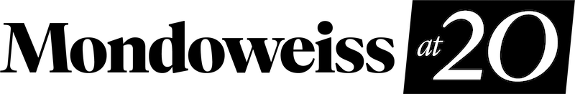

Dear Mondoweiss reader,
Over the last two and a half years, Palestine has finally become front-page news worldwide. Whether the devastating destruction Israel has wrought in Gaza, the Netanyahu government's role in pushing the war on Iran, or the Israel lobby's corrupting role in U.S. elections, it is nearly impossible to read news today without seeing Israel's fingerprints all over the stories that matter.
While these stories might come as a shock to some, Mondoweiss readers like you have been seeing them build for years.
Mondoweiss' reporting and analysis have been ahead of the curve, reporting the trends in both Palestine and the U.S., which become today's headlines. We have done so because we're close to the ground. With reporters based in Palestine and the U.S., and a network of contributors around the world, we have reported the stories and pushed the debates that matter.
And we've only been able to do this because of readers like you.
We are running out of time, and we need to raise $56,000 this month. Donate now and help sustain our editorial work. With your support, we will continue covering the stories shaping the narrative for years to come.

Fund our coverage

Our supporters give us the freedom to bring you the trailblazing reporting and analysis you have come to rely on. We are not beholden to institutional donors who help set the agenda – we are only accountable to our readers and the movement for Palestine.
Ensure we can continue telling the stories that need to be told and set the agenda for discussing Palestine.

Become a monthly donor

And while conditions in Palestine and Israel's pernicious role in our politics finally started to receive some mainstream attention, we all know it's not enough. The mainstream media, and even parts of the alternative media, are beginning to move on to the next story, but Mondoweiss is here for the long haul. Our staff is keeping their eyes on Gaza, the West Bank, and Israel's encroaching role across the region as others look away. We can only do so with your help.
Donate now to make sure Palestine doesn't fall out of the headlines, and we have the resources we need to keep all eyes on Palestine.
With urgency,
Adam

 |  | Adam Horowitz, Managing Editor  Mondoweiss

P.O. Box 442380, Detroit
Michigan, United States of America
You received this email because you signed up on our website or made a purch

