Reflections on the week's news. | View in browser





Israel passes a death penalty law for Palestinians as the Iran war grinds on

Last week, I wrote about how the Israeli far-right is not on the fringes of Israeli society; it is the center of it. As if to prove my point, the Israeli Knesset on Monday passed a new death penalty law targeting Palestinians, and National Security Minister Itamar Ben-Gvir celebrated on the Knesset floor with a bottle of champagne. In practice, it applies exclusively to Palestinians. The UN's human rights chief said its application to Palestinians would constitute a war crime and was "deeply discriminatory." Ben-Gvir and the other promoters of the law were gleeful.
Abdaljawad Omar explores the colonial history of racist applications of the death penalty to "pacify" Palestine. The British Mandate courts established military tribunals in 1937, designed to deliver quick death sentences. Shaykh Farhan al-Sa'di, a leader of the 1936 uprising, was "captured on a Monday, tried on a Wednesday, and hanged on a Saturday." The death penalty was applied to Palestinians for minor crimes, and Jewish defendants were given lighter sentences for more serious offenses. The current Israeli government is returning to "the darkest of these practices."
The disaster of the Iran war grinds on, and the disruptions to the global economy and the international system continue to spread. Trump appears to have no path out of the war, as Mitchell Plitnick lays out this week. The American people don't want it. Trump is proposing cutting basic services to pour more money into the military. What else is there to say about this debacle?
How do you think this is going to end?
Thanks for reading.

 |  | David Reed, Publisher  Articles / Support our work today

📺 New on The Shift podcast

Mondoweiss's Adam Horowitz and Michael Arria break down how this assassination attempt on activist Nerdeen Kiswani connects to a network of Zionist organizations with ties to the Israeli far right and even the Trump White House.

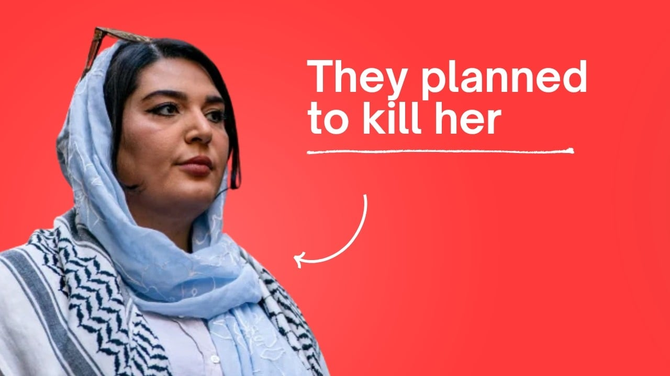

🇮🇷 The Iran war

Trump has no exit from the war he started, and the costs to the global economy, U.S. credibility, and the people of Iran keep mounting.
READ MORE → Trump has no good options to resolve the disaster he created in Iran — Mitchell Plitnick
READ MORE → A brief history of the Israeli nuclear program, the open secret at the heart of the Iran war — Anna Illing
READ MORE → Gaming the Iran war and the Gaza Genocide Syndrome — Robin Andersen.

🇮🇱 Israel's colonial project

The Zionist project of Israel's expansion is on full violent display across Palestine and the broader region.
READ MORE → 'The rope is for Arabs only': Israel's new death penalty law for Palestinians recycles a colonial playbook — Abdaljawad Omar
READ MORE → 'War crime': Global condemnation as Israeli ministers celebrate death penalty law targeting Palestinian prisoners — Qassam Muaddi
READ MORE → Israeli policies pose an existential threat to Palestinians in the West Bank. Why isn't there more resistance? — Qassam Muaddi
READ MORE → Barring Jerusalem Patriarch from Church of the Holy Sepulchre marks Israel's latest move to control Christian and Muslim sites — Jeff Wright
READ MORE → Israel is implementing its Gaza strategy in Lebanon: turning 'buffer zones' into permanent borders — Qassam Muaddi
READ MORE → When they come for the homes — Palestine-Global Mental Health Network

🚨 Repression and resistance

Support for anti-Palestinian violence shows up in American Jewish institutions and in the Democratic Party's ongoing deference to AIPAC, but resistance is pushing back and growing.
READ MORE → Plot to assassinate Palestinian activist follows harassment campaign promoted by Zionist groups and elected officials — Michael Arria
READ MORE → What is the JDL? Inside the Jewish extremist group inspiring anti-Palestinian terror in NYC. — Michael Arria
READ MORE → Prominent New York synagogue hosts presentation on why U.S. Jews should support the ethnic cleansing of Gaza — Philip Weiss
READ MORE → The Shift: The Democratic Party battle over AIPAC heats up — Michael Arria
READ MORE → Psychoanalysts are resigning from the International Psychoanalytical Association over its anti-Palestinian double standard — Palestine Mental Health Networks
READ MORE → 'Kuffiyehs in Buchenwald' campaign challenges Germany's anti-Palestinian culture of remembrance — Leon Wystrychowski

🇵🇸 Palestinian life under genocide

Palestinians in Gaza continue to endure the horrible conditions Israel created there. Salman Abu Sitta celebrates Palestinian resilience.
READ MORE → 'The rat gnawed my baby's cheek': Gaza tent encampments face rodent infestation — Tareq S. Hajjaj
READ MORE → Israel may dominate through violence, but Palestinians hold a force more powerful — Salman Abu Sitta

Advertisement - Learn more



