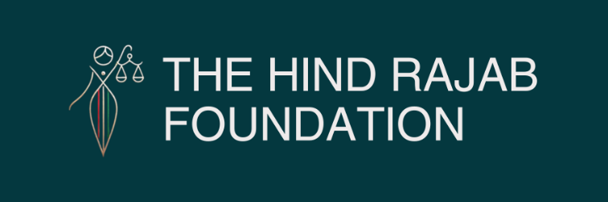

HRF and KAKTUS Submit Critical Complaint to Strengthen Poland Flotilla Investigation



Warsaw – 24/04/2026

Polish prosecutors have officially opened a criminal investigation into the October 2025 attack by Israeli forces on the Global Sumud Flotilla, triggered by an initial complaint filed by the injured parties.
Following the opening of this probe, the Hind Rajab Foundation (HRF) and KAKTUS – Polish Palestinian Justice Initiative submitted a critical supplementary legal package to the authorities. The Foundation provided a detailed forensic analysis of the chain of command, mapping the specific roles and responsibilities of the alleged perpetrators within the military hierarchy. This evidence, which alleges piracy, terrorism, and war crimes, is designed to ensure the investigation extends beyond individual acts of violence to address the systemic orders that authorized the interception of the unarmed humanitarian convoy. This case operates alongside HRF's parallel legal actions in England and a forthcoming case in a third country.

More details below.

SUPPORT OUR WORK

The Hind Rajab Foundation (HRF) welcomes the decision by Polish prosecutors to open an investigation into the October 2025 attack by Israeli forces on the Global Sumud Flotilla (GSF). This development marks a significant step toward accountability for attacks on unarmed civilian humanitarian missions.

HRF, in partnership with two injured parties and members of KAKTUS – Polish Palestinian Justice Initiative, submitted additional evidence concerning the unlawful interception of 42 humanitarian vessels and the arrest of 462 participants, including 15 Polish-flagged vessels and four Polish nationals. HRF has conducted a detailed analysis of the chain of command, identifying the roles and responsibilities of those allegedly involved in the operation. This material was presented to the Polish authorities to reinforce the ongoing investigation, ensuring that it addresses not only the alleged crimes but also the full spectrum of individuals who planned, facilitated, and executed them.


Polish investigation opens into the Global Sumud Flotilla attack, advancing justice for humanitarian missions challenging the Gaza siege
Strategic Legal Contribution

HRF's intervention focused on mapping the command hierarchy responsible for the interception of the flotilla. By delineating the responsibilities of the alleged perpetrators within the military structure and their exact role during the operation, HRF aimed to provide the most comprehensive list of individuals responsible for the attack.
This technical work complements the testimonies of the injured parties, Polish delegates Nina Ptak and Ewa Jasiewicz, who submitted additional evidence regarding alleged crimes of piracy, terrorism, and war crimes.
A Multi-Jurisdictional Strategy

The investigation in Poland is a key component of HRF's broader, multi-jurisdictional strategy to challenge impunity. The Foundation has already filed legal cases regarding the flotilla incidents in England and is currently preparing to initiate a similar case in a third country. These parallel efforts demonstrate a commitment to exhausting all available legal avenues to ensure that those responsible for international crimes face justice.

Nina Ptak, a human rights practitioner, highlighted the broader implications of these legal actions:

"This complaint is not about one abduction or imprisonment—it is a challenge to Israel's impunity, which, from Palestine to Lebanon and Iran, escalates unchecked as long as the world responds with silence or half-measures. It is not only about justice for us, but about bringing the world's attention back to where it should have been from the beginning—to Palestinians, who are being subjected to violence, dehumanisation, and torture. The urgency is even greater after Israel's recent adoption of the death penalty law, the effects of which are set to fall almost exclusively on Palestinians"

Commitment to Ongoing Advocacy

Natacha Bracq, Head of Litigation at the Hind Rajab Foundation, stated:

"The Hind Rajab Foundation is committed to holding accountable those responsible for international crimes against Palestinians. This includes attacks on civilian humanitarian missions heading to Gaza, such as the Handala, the Madleen, and the Global Sumud Flotilla. The interception of the flotillas in international waters, and the arrest and detention of their participants, were clearly unlawful. We commend the Polish authorities for opening this investigation and stand ready to provide our support."

As the investigation proceeds, HRF remains prepared to provide further legal analysis and evidence. Our focus remains on ensuring that the facts are thoroughly examined and that the legal process is robust enough to address the severity of the alleged violations.
Context of Continued Humanitarian Efforts

These legal developments coincide with the launch of a new, larger flotilla comprising 70 boats and 1,000 participants, aiming to break the siege on Gaza. Ewa Jasiewicz, whose testimony supports the current case, emphasized the continuity of the humanitarian mission:

"The Flotilla was an unarmed civilian convoy trying to do what states should be doing - prevent the crime of genocide. The blockade of Gaza and its starvation policy are a key element of Israel's genocide of the Palestinians. There has been no ceasefire; at least 765 Palestinians have been killed in Gaza since the 'ceasefire' took effect. Bombardment, starvation and deprivation of essential infrastructure, medicines, clean water and reconstruction continue. To Radoslaw Sikorski and Polish Government leaders, I say: do not look away, abide by your obligations under international law or you will find yourselves in the Hague. A thousand civilians, including Polish participants, are sailing to Gaza again to break Israel's illegal blockade when it should be Polish government policy to do so. It's not too late to sanction Israel, stop the genocide and bring perpetrators to justice."
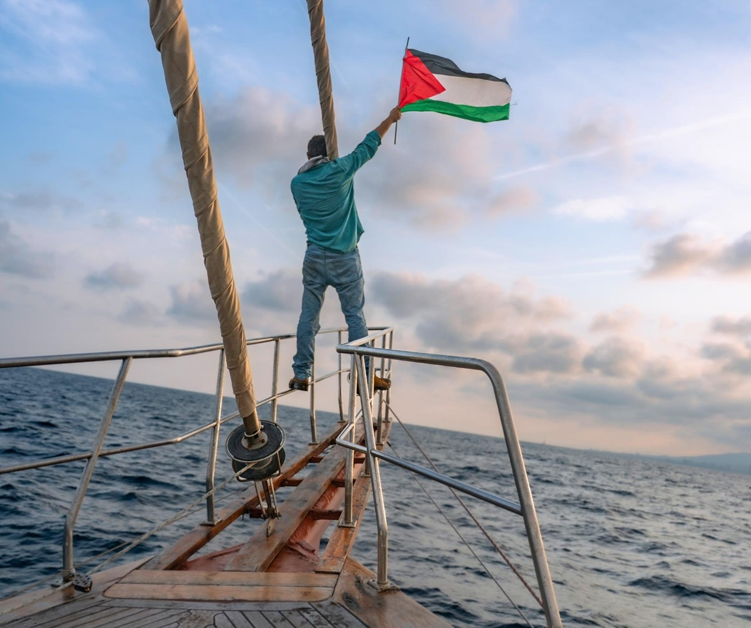
HRF advances its global accountability campaign with new legal filings on the Global Sumud Flotilla in Poland, building on existing cases in England and preparations for a third jurisdiction

Alina Palichleb, Head of the Polish Delegation for the current Global Sumud Flotilla, reinforced the legal and moral imperative of their mission:

"We know that the Israeli authorities have no right to stop the flotilla. We are unarmed and pose no threat. This is part of Israel's ongoing effort to isolate Palestinians from any form of contact with the outside world. As a person of Palestinian heritage, I call on the EU and the Polish government to act without delay. If they recognize the Palestinian Authority, they should also demand the opening of the borders, initiate trade relations, create university programmes, and support tourist access to Palestine and its renowned hospitality. Palestinians have preserved a heritage that belongs to all humanity, and they are a nation that can thrive and continue to contribute to our shared future, while standing steadfast against a brutal occupation and the deafening silence of the EU"

The Hind Rajab Foundation continues to monitor these developments closely, supporting the global movement for accountability and the protection of humanitarian workers.

