Book Review: The weight of witnessing
Wasim Said’s “Witness to the Hellfire of Genocide: A Testimony from Gaza” documents a genocide that continues to unfold. It is a record of what the world allowed to happen, and what the world will continue to allow unless we stop it.
BY SHATHA MAHMOUD DECEMBER 6, 2025 0
FACEBOOKXWHATSAPPLINKEDINMASTODONBLUESKYREDDITEMAILPRINT
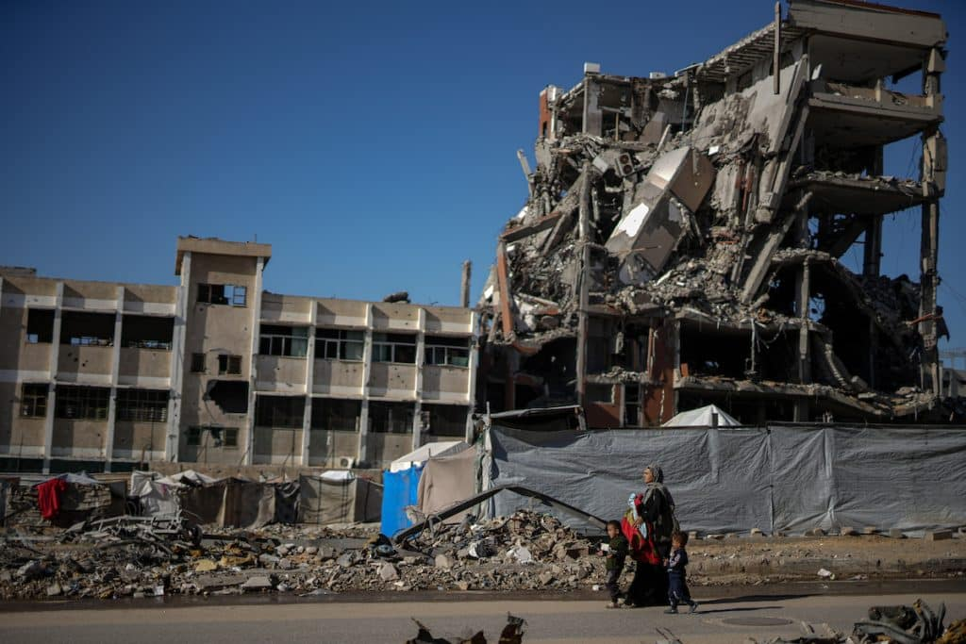DISPLACED PALESTINIANS STRUGGLE WITH FLOODING AFTER HEAVY RAIN HITS THE TAL EL-HAWA AREA IN GAZA CITY, ON NOVEMBER 30, 2025. (PHOTO: OMAR ASHTAWY/APA IMAGES)
WITNESS TO THE HELLFIRE OF GENOCIDE
A Testimony from Gaza
By Wasim Said
85 pp. 1804 Books, $16.95
BUY IN THE MONDOWEISS BOOKSHOP
Wasim Said’s Witness to the Hellfire of Genocide: A Testimony from Gaza is a text born beneath drones, amid the roar of bombs, among the starved and displaced, and within the ruins and rubble of the Gaza Strip. Published by 1804 Books, it stands as one of the earliest written testimonies to emerge from the strip while the genocide it documents continues to unfold. Said is a 24-year-old physics student from Beit Hanoun in northern Gaza, a town that faced some of the greatest levels of destruction in the beginning stages of the genocide.
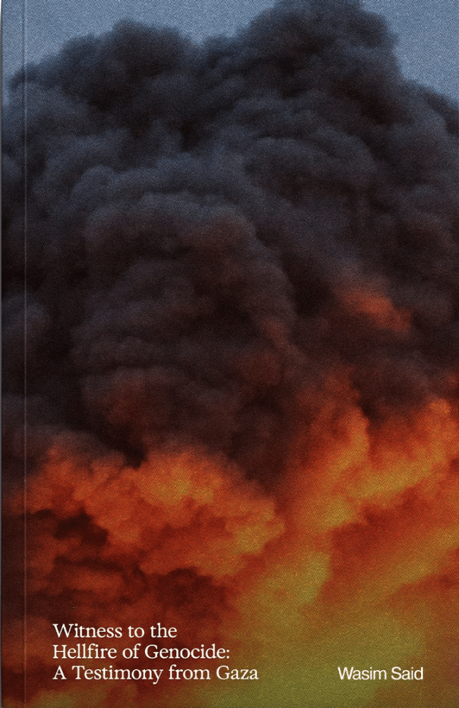
Said began writing during the brief January 2025 ceasefire, hoping it would mark the beginning of return and recovery. But before he could finish his first chapter, Israel broke the ceasefire, and his writing transformed from reflection to a living record written through displacement, hunger, and bombardment.
Reading Wasim Said’s Witness to the Hellfire of Genocide: A Testimony from Gaza feels like an impossible act, not because it’s difficult to understand, but because understanding it demands a moral confrontation. It is a book that refuses refuge.
One that makes clear from page one that it is not a literary exercise, but a political and moral positioning.
In his introduction, Said states the purpose of his testimony and the demand it places on the reader:
“I didn’t write this to make you cry.
I write it so I can hang these words around your neck-
to make you bear the responsibility of my perspective,
the responsibility of knowing,
the responsibility of being a witness.”
There’s a silence that follows these words, the silence of confrontation. To read this book is to stand face-to-face with our own participation in the world that made it possible. It forces us to see genocide not as a rupture in the order of things, but as its fulfillment. Not a “crisis” but a system, one administered, funded, normalized, and made invisible by global complicity.
Once you’ve read those words, you can no longer return to the safe distance built between you and the images of death and decay you scroll past on your social media feed. The distance is gone. You are inside the frame.
Wasim refuses the reader’s position of spectator. His testimony, written from within the genocide—during bombardment, starvation, and displacement—makes spectatorship itself unbearable. His words indict not only the perpetrators but the global public whose silence sustains the conditions of genocide.
We are not reading from outside the event. We are reading as participants in its construction.
Every government that armed the Zionist entity, every corporation that profited from its slaughter, every institution that lent its barbarism credibility, every newsroom that ran interference and whitewashed its massacres, and every spectator that stood by while Gaza starved- each is a thread that is woven into the fabric of genocide.
It is a fabric that we are still wearing.
Wasim writes from the heart of the empire’s moral collapse, and in doing so, he leaves the reader with a question: What do we do with the weight of witnessing?

Importance of Documentation: Writing as Refusal
Wasim Said drafted his chapters in the darkness of the night in make-shift tents, which he describes as “made up of wooden boards and iron rods covered by cloth or nylon”, guided by the weak beam of a phone flashlight he’d have to ration between writing and survival. This is not a writer reflecting on or returning to memory; it is a writer documenting the world deteriorating around him. This book is not a recollection; it is testimony in real time.
In Palestine, writing has always been intertwined with survival. For a people who’ve been expelled from their land, stripped of their citizenship, and rendered disposable by global consensus, the act of recording becomes an act of refusal. It is a means of refusing disappearance. It is how a people who have been denied a history insist on their existence.
Palestinian writing has always emerged from within the struggle. Ghassan Kanafani wrote through exile, through the mass ethnic cleansing of 1948, mapping memory onto a geography that was systematically stolen. Walid Daqqah smuggled his work from inside an Israeli prison, writing through iron bars. Wisam Rafeedie composed Trinity of Fundamentals from solitary confinement, each page smuggled out through his comrades. Refaat Alareer edited and taught literature in Gaza until the very week he was assassinated by an Israeli strike, his work refusing to cede language to the occupier. All of these writers composed their work while the violence was still unfolding, not after it ended. They didn’t wait for safety, distance, or recognition. They wrote while under curfew, under siege, in prison cells, and under bombardment.
Wasim belongs to that lineage. He writes under the cloth of a displacement tent, while water runs out, and the smell of death hangs heavy in the air. Every sentence he writes is composed under the shadow of a drone.
“I write as I gasp for breath between the shells; I write, and each word might be the last.”
A document produced not in the past tense of tragedy, but in the present tense of annihilation. This distinction matters because most genocide literature we know today is post-event: written from exile, memory, or survival. But Wasim’s testimony has no aftermath to reflect from.
He writes from the middle of the story, and the book’s structure follows his trajectory through the genocide. It begins with his displacement from Beit Hanoun, the repeated attempts of him and his family to find shelter, and the starvation that chokes and governs what’s left of life in the strip. He shares his account of having to hunt for flour, the massacres at the so-called aid sites, and the lines of people waiting for a crumb of bread under the hum of drones. Said then covers stories from the north, the region Israel deliberately starved and cut off from the rest of the strip, and has faced the greatest levels of engineered famine and mass death.
At the end, the book delves into a section called ‘Martyrs without witnesses’, where he documents what the world refuses to see: children burned alive in classrooms, hospitals under siege, families forced to store their mother’s body in a refrigerator because snipers hunted even the dead. Its organization is an indictment; each chapter reveals another layer of a genocide orchestrated to leave no one left to remember, no one left to speak, and no one left to witness.
Documentation, for Wasim, is not memory; it is continuity. It prevents the process of annihilation from completing itself. By recording, he denies the empire the last word.
As long as these words exist, Gaza cannot be erased.

Writing within Death: The Material Conditions of Genocide
Wasim Said doesn’t write from the edges of catastrophe; he writes from the centre of a global project that has been unfolding for decades, long before October 7.
Since the enforcement of the suffocating siege in 2007, Israel, with full backing from the Western world, has turned Gaza into an engineered site of mass death. A laboratory where every method of policing, surveillance, population control, and urban warfare is tested on Palestinians before being exported to the world. These are the conditions under which each page of this book is written.
The genocide in Gaza is not chaos. What Wasim records is not spontaneous destruction but the deliberate orchestration of annihilation. The siege that entraps him, and that shapes every sentence of this book, is one of the most organized projects of mass suffering in modern history.
When hospitals are bombed, it is not a military accident. It is the destruction of a population’s capacity to live. When bakeries, sewage treatment plants, and solar panels are targeted, it is not collateral damage. It is the elimination of the civilian infrastructure that sustains life.
“Humanitarian zones” are announced, only to become mass graves. “Evacuation orders” translate to forced displacement. “Safe zones” are bombed hours after their declaration.
Starvation, too, is policy. Israel has perfected what it calls “mowing the grass,” a doctrine of routine annihilation that keeps Gaza perpetually uninhabitable. The siege cuts off food, fuel, and medicine; it controls the calorie intake of two million people; it decides who may eat, who may live, and who must die. When Wasim describes people boiling leaves for food or scavenging sewage water to drink, he’s not only describing famine, he’s describing policy.
These policies are the architecture of genocide, the blueprint of a settler-colonial enterprise that survives through the extermination of the Palestinian people.

Unmasking the Enablers: Genocide as Global Structure
Wasim doesn’t describe the weapons that pulverize Gaza as distant or anonymous machinery; he writes about them through the lens of those who endure them. When aircraft drop cluster bombs on displaced families sleeping in classrooms, he describes them as he witnessed them: products “made in the land of ‘freedom and democracy’”. He names what the world’s genocide enablers prefer to obscure: that every explosion, every missile, every sniper shot is not a distant barrage of violence in Gaza’s sky, but the material implication of a global order that profits from its fire. Wasim’s testimony makes it clear that the weapons do not simply arrive in Gaza- they are sent.
The bombs dropped on Gaza were not made there. The weapons that have flattened entire cities were not assembled in Rafah or Khan Younis. They were produced in the United States, financed by tax dollars, and assembled across a transnational supply chain that links together corporations, states, and financiers from Canada to the Netherlands and the United Kingdom. Israel’s primary bomber aircraft, the F-35I “Adir,” is manufactured with components and a supply chain that span the globe.
The world’s second-largest shipping carrier, Maersk, was exposed in 2024 for transporting millions of pounds (lbs) of military cargo to Israel from the U.S.
Even the digital infrastructure of genocide is outsourced. Google and Amazon’s Project Nimbus powers the Israeli military’s data systems, providing the surveillance and AI capacity that guide targeting operations. Western banks invest in arms manufacturers like Elbit Systems and Lockheed Martin – companies whose profits rise with every massacre. Gaza’s destruction is not just militarily sustained; it’s economically incentivized.
This is the world Wasim’s words force us to confront: a world in which genocide is not the act of a single state, but a global division of labour- an international collaboration.

Living Memory, Active Responsibility
This is not a book review. It’s a reckoning.
What Wasim offers us is an indictment and an invitation. Not an invitation to commemorate, but to commit. Once you’ve entered this book, once you’ve carried its words, you cannot pretend you are standing outside the story. You are in it.
To read Witness to the Hellfire of Genocide is to understand that Gaza is teaching us something about the world. It is a record of what the world allowed to happen. And what the world will continue to allow unless we act.
This book leaves us with a responsibility that cannot be carried alone, a responsibility of the living to the living.
Responsibility to the people still breathing under siege.
To the child standing where her school once was.
To the prisoner still held in the occupation’s dungeons.
To the families who have memorized their children’s faces for fear their bodies won’t be found.
To those who refused to die quietly – our martyrs.
Our martyrs whose bodies return to the land that never released them, who return to the soil that held their names and those who came before them, whose sacrifice will never be forgotten – not a memory to hold, but a responsibility to carry.
Our responsibility is not to feel devastated. It is to devastate the systems that made this book possible.
We are not helpless. We are positioned.
We are not distant. We are implicated.
And so the final question is not: What did this book make you feel?
The question is: What will this book make you do?

