

Voters are breaking with the Israel lobby faster than Washington can catch up

Voters in Michigan handed pro-Palestinian and anti-establishment candidates 11 out of 16 contested primary races this month, while AIPAC burned through more than $30 million trying and failing to stop Abdul El-Sayed's Senate run. Tom Perkins reports on what the wins mean for Michigan's most pro-Palestinian slate of elected officials in the state's history.
In Florida's 25th district, DSA member and union organizer Oliver Larkin is challenging Jared Moskowitz, one of the most reliably pro-Israel votes in the House. Michael Arria looks at how the fight over Israel policy is playing out across multiple Florida primaries, from Angie Nixon's Senate bid to the AG's race against the New York Times.

The Trump administration is prosecuting activists under anti-terrorism statutes and campaigning to dismantle the International Criminal Court. Mondoweiss has spent 20 years reporting honestly on Palestine. We need your support now to confront these threats to independent news media.

 |  | David Reed, Publisher  Articles / Support our work today

📺 WATCH: The Shift: Abdul El-Sayed Overcame $30 Million from AIPAC and Won Michigan

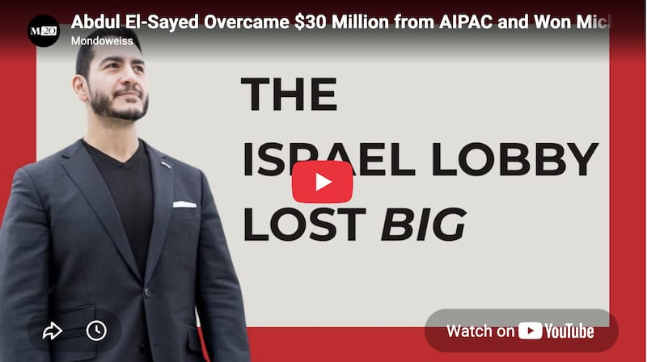

Subscribe to our YouTube channel!

🇺🇸 U.S. politics and the Israel lobby

The Israel lobby's grip on Democratic primaries continues to slip. Universities are stepping into the enforcement role that AIPAC once left to campaign spending.
READ MORE → Power & Pushback: Carnegie Mellon investigating students over pro-Palestine messages — Michael Arria
READ MORE → The Mecca Pact is the latest sign of the U.S.'s declining influence in the Middle East — Mitchell Plitnick
READ MORE → The Shift: One of Congress's most pro-Israel members is facing strong opposition from an anti-Zionist in Florida — Michael Arria
READ MORE → Pro-Palestinian advocates won big in Michigan – what comes next? — Tom Perkins

🇵🇸 West Bank and Gaza

In Gaza, children are clearing rubble by hand for $10 a day, and a press corps is decimated by targeted killings. In the West Bank, refugee camps are under renewed military threat, a community doctor is imprisoned, and farmers are racing settler cattle to bring in the wheat harvest.
READ MORE → Palestinian youth are risking their lives to clear rubble in Gaza — Tareq S. Hajjaj
READ MORE → Entrusted with Palestine: Honoring the martyred journalists of Gaza through action — Palestinian Youth Movement
READ MORE → Understanding Israel's campaign to destroy Palestinian refugee camps in the West Bank — Qassam Muaddi
READ MORE → 'Is this how our story ends?' Palestinian refugees live in fear as Israel takes aim at West Bank camps — Aseel Mafarjeh
READ MORE → Israel's arrest of Ramallah's 'doctor of the poor' shows Palestinians that no one is safe — Mondoweiss Palestine Bureau
READ MORE → The struggle to save the Palestinian wheat fields on the front lines of Israeli settler violence — Majd Jawad
READ MORE → Palestine Letter: the language of Palestinian reality — Qassam Muaddi

