

Brussels – 16/02/2026

The Hind Rajab Foundation has filed a criminal complaint in Chile against Israeli-Ukrainian sniper Rom Kovtun for genocide, crimes against humanity, and war crimes committed in Gaza.
The case centers on his participation in the siege and destruction of Al-Shifa Hospital, one of the most serious attacks on protected medical infrastructure during the genocide.
This action is part of a global effort to ensure that those responsible for the Gaza genocide face justice wherever they travel.
More details below.

SUPPORT OUR WORK

HRF Files Criminal Complaint in Chile Against Sniper for War Crimes in Gaza

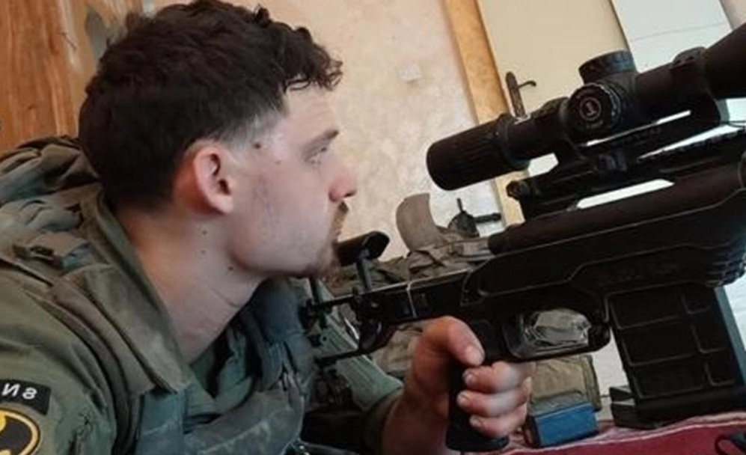

The Hind Rajab Foundation (HRF) has filed a criminal complaint before the 8th Guarantee Court of Santiago, Chile, seeking the investigation and prosecution of Rom Kovtun under Chile's Law 20.357, which criminalizes genocide, crimes against humanity and war crimes in accordance with the Rome Statute.
The complaint was formally submitted by Chilean lawyer Pablo Andrés Araya Zacarías, partner at Silva-Riesco Abogados and acting on behalf of HRF. The filing invokes universal jurisdiction, activated by Kovtun's physical presence in Chile.

The Accused and His Operational Role

According to the complaint, Rom Kovtun, an Israeli-Ukrainian, served as a sniper in the 424th "Shaked" Battalion of the Givati Brigade, operating under the 401st Armored Brigade during Israel's large-scale operations in Gaza.
The filing details his alleged participation in the siege and destruction of Al-Shifa Hospital between March and April 2024 — an operation that resulted in massive destruction of medical infrastructure and reported civilian deaths, including patients and medical staff.
The complaint alleges that Kovtun:
- Participated in the encirclement and military control of the hospital compound;
- Operated as part of sniper positions surrounding the facility;
- Contributed to sustained lethal fire in and around the hospital perimeter;
- Took part in conditions that prevented safe evacuation of civilians;
- Contributed to circumstances that led to deaths caused by deprivation of food, water, medical care and humanitarian access.
Following the withdrawal of Israeli forces, reports documented mass graves, widespread destruction, and severe damage to the largest medical complex in Gaza.

Legal Characterization of the Conduct

Under Chile's Law 20.357, the complaint qualifies the alleged conduct as crimes against humanity for participation in a widespread or systematic attack directed against the civilian population, including subjecting civilians to conditions of existence leading to death or serious harm; as genocide for contributing to the deliberate infliction of conditions of life calculated to bring about the physical destruction, in whole or in part, of a protected national group; and as war crimes, including attacks against civilians, attacks against protected medical facilities, and the destruction of civilian property not justified by military necessity. The complaint further argues that the siege of a functioning hospital — a specially protected object under international humanitarian law — constitutes one of the gravest categories of violations.
Jurisdiction of the Chilean Courts
The filing sets out the legal basis for Chilean jurisdiction by noting that Chile has ratified the Rome Statute and the Geneva Conventions, and that Law 20.357 codifies genocide, crimes against humanity, and war crimes into domestic law. It further explains that universal jurisdiction is recognized in Chilean jurisprudence, that Kovtun is physically present in Chile, and that Israel has not prosecuted the alleged crimes. On this basis, the complaint asserts that Chilean courts are legally competent and obligated to act. HRF has therefore requested that the court admit the complaint, open a formal criminal investigation, assign the Human Rights Crimes Brigade (BRIDEHU) to conduct investigative measures, locate and interrogate Kovtun, and impose precautionary measures preventing his departure from Chile.

Statements from HRF
"
The targeting and destruction of a functioning hospital during a military siege strike at the core of international humanitarian law," said Dyab Abou Jahjah, General Director of HRF. "When evidence indicates that a sniper participated in such an operation, domestic courts cannot look away. Universal jurisdiction exists to ensure that the most serious crimes do not go unexamined simply because they were committed abroad.
"
Natacha Bracq, Head of Litigation at HRF, emphasized the evidentiary foundation of the case:
"
International humanitarian law grants special protection to hospitals, medical personnel, and the wounded," said Bracq. "The encirclement and destruction of a functioning medical complex, combined with the deprivation of food, water and medical care, are not collateral damage — they constitute war crimes, crimes against humanity, and acts of genocide.
"
Chilean counsel Pablo Andrés Araya Zacarías stated:
"
Chile has ratified the Rome Statute and incorporated it into domestic law through Law 20.357. That creates a legal obligation to ensure that those accused of genocide, crimes against humanity, and war crimes do not find refuge here. The requirements for universal jurisdiction are clearly met, and we are confident the court will declare the complaint admissible and proceed with the investigation.
"
A Global Strategy to End Israeli Impunity

This filing in Chile forms part of the Hind Rajab Foundation's broader global strategy to ensure that individuals credibly accused of the gravest international crimes committed during the Gaza genocide are held to account wherever they travel. HRF has initiated proceedings and filed complaints invoking universal jurisdiction in multiple countries, triggering official investigations and legal scrutiny across jurisdictions in Latin America, Europe, and North America. These actions, alongside extensive submissions to the International Criminal Court and domestic prosecutors worldwide, are aimed at dismantling the longstanding architecture of Israeli impunity. Universal jurisdiction is no longer theoretical — it is being activated in courtrooms. Chile now has the opportunity to mark an important step in this global quest for justice by demonstrating that presence on its territory carries legal consequences. Ending impunity begins with enforcing the law.

