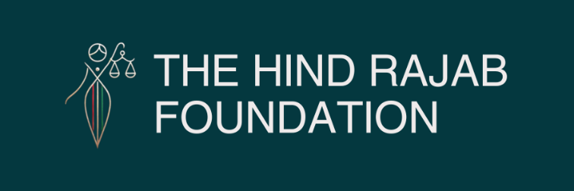

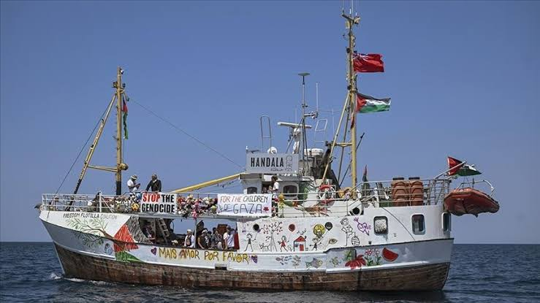

The Hind Rajab Foundation has filed a war crimes complaint in the UK over Israel's armed raid on the Handala — a British-flagged humanitarian ship bringing life-saving aid to Gaza. Israeli forces seized the vessel in international waters, abducted 21 unarmed civilians, and confiscated its cargo. We are holding Shayetet 13 and Navy Commander David Saar Salama accountable for this blatant attack on UK sovereignty, international law, and the right to deliver humanitarian relief. Justice must sail where they tried to silence it.

Read the full press release below.

SUPPORT OUR WORK

28 July 2025 — London
The Hind Rajab Foundation has today filed a formal criminal complaint with the UK Metropolitan Police War Crimes Unit regarding the Israeli military assault on the British-flagged humanitarian vessel Handala in international waters on the night of 26–27 July 2025​
The complaint, lodged under the Geneva Conventions Act 1957 and the International Criminal Court Act 2001, urges UK authorities to open an immediate investigation into grave breaches of international law and war crimes committed by Israeli forces.
The assault was carried out by the Shayetet 13 naval commando unit, under the command structure of the Israeli Navy, whose Commander-in-Chief is Vice Admiral David Saar Salama. The complaint also targets officials within the Israeli military and government who may have authorized, planned, or facilitated the operation. The Hind Rajab Foundation is calling for these individuals to be identified, investigated, and—where evidence permits—prosecuted or arrested under UK jurisdiction.
At the time of the raid, the Handala was sailing approximately 49 nautical miles off the coast of Gaza, carrying 21 unarmed civilians, including:

Chloé Fiona Ludden, a British humanitarian volunteer
Emma Fourreau, Member of the European Parliament (France)
Gabrielle Cathala, Member of the French National Assembly
Jacob Berger, a Jewish-American activist
Journalists, lawyers, and aid workers from 12 countries
All were detained without legal basis and forcibly taken to Israel.

​The ship's humanitarian cargo—baby formula, medical supplies, and food—was confiscated, and communications were cut immediately after Israeli forces boaed the vessel.
The Handala is a British-flagged vessel, and as such, constitutes an extension of UK sovereign jurisdiction. The seizure of the ship and arrest of its passengers in international waters constitutes an assault on British legal territory, a violation of the UN Convention on the Law of the Sea (UNCLOS), and a grave breach of the Fourth Geneva Convention. It also directly defies the binding orders of the International Court of Justice, issued in early 2024, which require the unimpeded delivery of humanitarian aid to Gaza.
The Hind Rajab Foundation is requesting the following from UK authorities:

Immediate opening of a criminal investigation into the operation;
Identification and questioning of all 21 passengers, especially UK nationals;
Legal action against Vice Admiral David Saar Salama, Shayetet 13 commanders, and any political or military officials responsible;
Placement of suspects on watchlists and preparation of arrest warrants for any who may enter the UK;
Coordination with Interpol, the International Criminal Court, and UN mechanisms to ensure international accountability.

This case follows the pattern of previous illegal interceptions, including the recent attack on the Madleen and the 2010 Mavi Marmara raid. The Handala incident is not isolated—it is part of a systematic campaign to criminalize humanitarian aid and suppress civilian solidarity with Gaza under the guise of military enforcement.
The Hind Rajab Foundation will not relent.
We are committed to exposing and confronting every act of illegality and brutality carried out under the cloak of state power. The attack on the Handala is an attack not only on aid workers and civilians—but on international law, human dignity, and the very principle of accountability.
Justice must be done. The perpetrators must face consequences.

