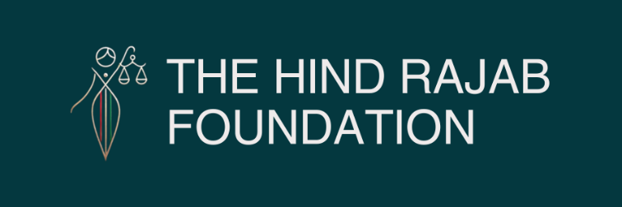

BREAKING:After HRF Filings, 3 Probe Orders Issued By Prosecutors in Brazil Against IDF Soldiers

Brussels / Brasília – 13 March 2026

Brazil's Public Prosecutor has ordered three criminal investigations following complaints filed by the Hind Rajab Foundation against Israeli soldiers linked to crimes committed in Gaza. The decision confirms that Brazil recognizes its jurisdiction to investigate these international crimes.

In the hours following the order, one suspect was smuggled out of Brazil by Israeli actors, while two others are now on the run.

The Federal Police has appealed the Prosecutor's probe orders instead of executing them, raising serious concerns about obstruction and delays in a case that directly tests Brazil's commitment to the rule of law.

More details below.

SUPPORT OUR WORK

Brazil Orders Investigations into 3 Israeli Soldiers After HRF Filing; One Smuggled Out, Two Still at Large



The Hind Rajab Foundation (HRF) confirms that the Brazilian Public Prosecutor's Office has issued three probe orders directing the Federal Police to open investigations into Israeli soldiers present in Brazil, following complaints filed by HRF concerning crimes committed during Israel's military campaign in Gaza.
The decision, issued on 4 March 2026, states that it is "imperative to initiate a police investigation." In doing so, the Prosecutor referred the complaints to the Regional Superintendency of the Federal Police in the Federal District, requesting the urgent initiation of investigative measures.
HRF considers this decision an important legal development and a clear acknowledgment of Brazil's jurisdiction and responsibility under international law, including the principle of universal jurisdiction, to investigate serious international crimes when suspects are present on its territory.

HRF Complaints Concerning Israeli Soldiers in Brazil

The complaints filed by HRF concern several Israeli soldiers located in Brazil, including individuals identified in the municipalities of Ilha do Campeche (Santa Catarina), Itacaré (Bahia), and on the island of Morro de São Paulo (Cairu, Bahia).
Among those named in the filings is Omri Turgeman, a soldier in the 424th Infantry Battalion "Shaked" of the Givati Brigade, whose unit has been linked to grave crimes committed during Israel's operations in Gaza.
HRF's complaints present evidence connecting the suspects to war crimes, crimes against humanity, and acts that form part of the broader genocidal campaign against the Palestinian population in Gaza.

Israeli Obstruction of Justice

Following the issuance of the Prosecutor's probe orders, HRF has obtained information indicating that Israeli actors have moved to obstruct the judicial process.
According to information available to HRF, one of the soldiers identified in the complaints has already been smuggled out of Brazil.
These developments raise serious concerns about active obstruction of justice aimed at preventing accountability for international crimes.

Federal Police Appeal Raises Concerns

At the same time, HRF has received a concerning response from the Brazilian Federal Police, which has appealed the Public Prosecutor's decision instead of executing the probe orders.
The appeal raises several arguments, including statements that question the relevance of the International Criminal Court's proceedings and claim that investigations carried out in Brazil into crimes committed in Gaza would be ineffective.
HRF notes that no meaningful investigative measures appear to have been undertaken, despite the Prosecutor's clear determination that a police investigation must be initiated.
While HRF recognizes that investigations based on universal jurisdiction can present practical challenges, such challenges cannot serve as a legal justification for refusing to investigate or failing to fulfill Brazil's obligations under international law.
The position taken in the police appeal also appears to disregard the arrest warrants issued by the International Criminal Court against Israeli Prime Minister Benjamin Netanyahu and former Defense Minister Yoav Gallant, as well as Brazil's obligations under the Rome Statute and the Geneva Conventions to investigate and prosecute international crimes.

HRF Statement

Dyab Abou Jahjah, General Director of the Hind Rajab Foundation, emphasized the broader implications of the case:
"
What we are witnessing here goes beyond a single investigation. It is part of a global struggle between accountability and impunity. When prosecutors recognize jurisdiction over crimes committed in Gaza, they reaffirm a basic principle of international law: perpetrators of genocide and war crimes cannot travel the world as if nothing happened. Attempts to smuggle suspects out of Brazil only confirm how necessary these investigations are.
"
Natacha Bracq, Head of Litigation at HRF, stressed the legal obligations involved:
"
HRF's work is grounded in international law and the fundamental duty to prevent and punish genocide. As a State Party to both the Geneva Conventions and the Genocide Convention, Brazil has a clear legal obligation to investigate individuals suspected of committing international crimes on its territory. We have submitted evidence and remain ready to support the Federal Police in this effort. Any failure to act would represent a serious breach of Brazil's international legal obligations.
"
A Test For The Rule of Law

The issuance of three probe orders by the Brazilian Public Prosecutor marks an important step in the application of universal jurisdiction to crimes committed in Gaza.
At the same time, the removal of suspects from Brazilian territory and the apparent reluctance of the Federal Police to execute the Prosecutor's order raise serious concerns about the ability of the justice system to carry out investigations free from political pressure or obstruction.
Brazil now faces a decisive moment. The question is whether the investigations ordered by the Prosecutor will be carried out fully and independently, or whether those implicated in crimes against the Palestinian population of Gaza will once again evade accountability.

