

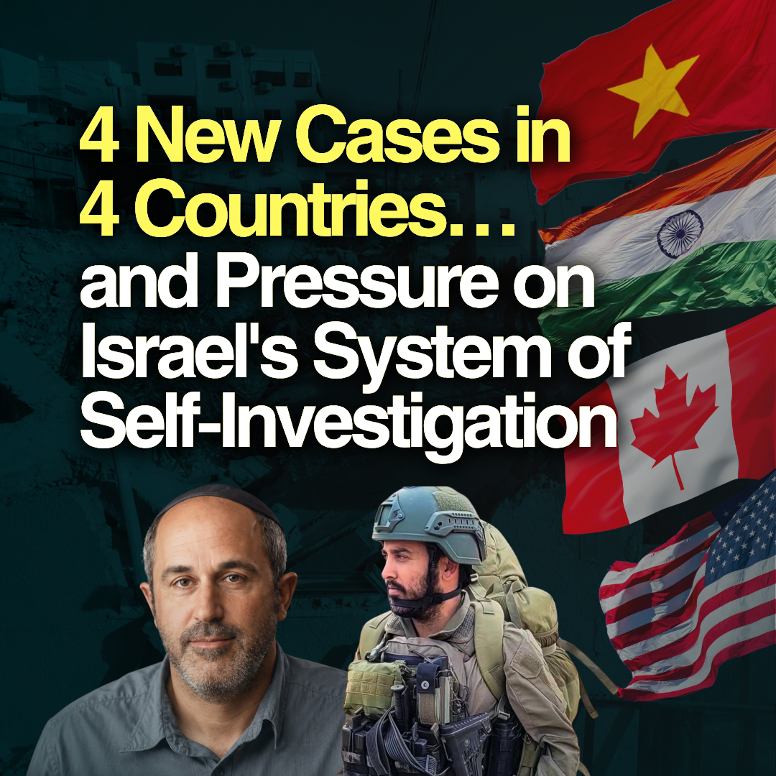

Last month, the Hind Rajab Foundation (HRF) opened new legal fronts in Vietnam, India, Canada, and the United States, pursuing Israeli soldiers and officials alleged to have participated in war crimes, genocide, incitement, and the unlawful transfer of Palestinians.

Each filing opens another jurisdiction, invokes another state's legal obligations, and further narrows the geography of impunity.

Here is what we filed in August, and why each case matters.

SUPPORT OUR WORK

Vietnam

HRF filed a criminal complaint with Vietnamese authorities against Matan Jerafi, an Israeli reservist on holiday in Vietnam, who serves in the 920th Infantry Battalion, 769th Brigade, and is CEO of the Israeli organization Im Tirtzu.

Jerafi documented his own deployments. The complaint concerns his role in the systematic destruction of civilian infrastructure in central Gaza and later in southern Lebanon. It also details a sustained public record of statements calling for the starvation, expulsion, and killing of Gaza's civilian population.

Vietnam is party to the Geneva Conventions and the Genocide Convention. Those obligations do not pause for a suspect's holiday.

India

HRF's second complaint in India this year concerns an Israeli soldier vacationing in the country, alleged to have taken part in the systematic destruction of civilian property in the Khan Younis Governorate, between March and April 2024.

Satellite imagery, verified footage and open-source analysis show the demolitions occurred after Israeli forces established operational control of the area—not during combat: destruction as policy, not as consequence. The pattern matches Amnesty International findings on Israeli "buffer zone" demolitions along Gaza's eastern perimeter.
India has legal obligations under the same conventions as Vietnam. HRF's filings demand these obligations are fulfilled.

Canada & the United States

Legal action also produced concrete results in Canada, with a criminal complaint filed by HRF and its partners at the Legal Centre for Palestine leading to the revocation of the Electronic Travel Authorization of Arieh King, Deputy Mayor of Jerusalem and founder of the Israel Land Fund. King was subsequently forced to cancel an in-person speaking engagement in Toronto on 25 August.

Ahead of King's arrival in the United States on 31 August, HRF filed a request for his prosecution with the U.S. Department of Justice for the war crime of unlawful transfer through the decades-long dispossession of Palestinians in Occupied East Jerusalem, particularly Silwan and Sheikh Jarrah, and incitement to genocide.
The complaint also documents King's campaign against UNRWA, an organization whose destruction has been central to the starvation of Gaza, and his public calls for the expulsion of Gaza's population and destruction of its cities.

King was not coming to Canada and the U.S. to hide. He was coming to raise funds for Israel's genocidal projects.

Accountability will not be left to the perpetrators

As HRF pursues criminal cases across jurisdictions, Israel has announced self-investigations into two of the more notorious crimes committed by its forces in Gaza:
- The killing of six-year-old Hind Rajab, members of her family, and the two PRC paramedics sent to rescue her; and
- The killing of 15 Palestinian paramedics and emergency workers in Rafah.

These investigations come after more than two and a half years of genocide, despite extensive independent documentation and evidence of the crimes committed. For 933 days, the Israeli military denied responsibility for Hind's killing.

It has now opened a criminal investigation focused on failures in coordinating the ambulance sent to rescue her, rather than the central question: Who killed Hind Rajab?

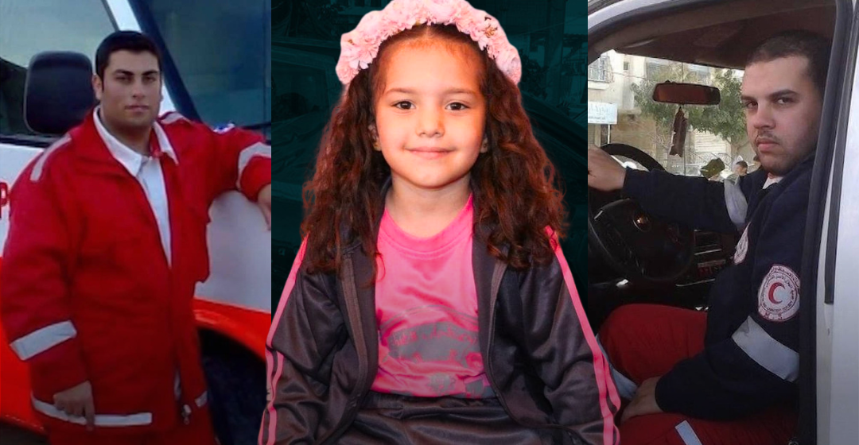

We know the unit, the commanders, the soldiers present, and the tank that fired.
We know who killed Hind Rajab.

The problem isn't a lack of evidence. It's a system that consistently shields its own forces from accountability. Over 1,000 incidents related to Israel's assault on Gaza have been referred to Israel's Fact-Finding Assessment Mechanism. Only 74 investigations have been opened. Only one has resulted in a prison sentence.

These belated self-investigations create the appearance of accountability while deflecting international pressure. As importantly, they aim to undermine the substantial gains being made in these cases before foreign and international courts.

Our work is to ensure Israel cannot investigate itself out of accountability.

