Gaza, Trump’s UN “peace” plan, and the media ecosystem deciding what you see. | View in browser



The Israel lobby’s crisis and what comes next

Next week, we launch our end-of-year fundraising campaign to sustain Mondoweiss into its twentieth year. Our goal is to raise $217,500, and thanks to generous donors, we already have $62,000 in matching funds that will double the impact of your contribution. For nineteen years, Mondoweiss has been part of the backbone of the Palestinian movement, providing reporting and analysis that organizers, educators, and community leaders rely on. If you already know you want to support this work, you can make a donation now; we will count it toward the campaign, and you will not receive the fundraising emails that begin on December 11. The stories in this week’s newsletter show why this kind of independent media is so important, as our reporters and contributors track how the genocide in Gaza is being repackaged and how people around the world are fighting back.
This week, Tareq Hajjaj reports on how Israel is using the “ceasefire” to tighten the siege on Gaza, blocking aid, starving people, and letting hospitals run out of basic supplies while calling it “stabilization.” A story we’ve covered throughout this war is that Israel relied on Palestinian collaborators like Yasser Abu Shabab, a gang leader who looted aid convoys and helped the army control desperate civilians. Abu Shabab was killed this week, and Tareq has that story as well. Craig Mokhiber dissects the UN Security Council’s colonial “mandate” for Gaza. Foreign powers are claiming the right to manage Palestinian lives while the people themselves are treated as a problem to be contained, not a nation to be freed. Gaza is not in a postwar reconstruction phase. The genocide continues, but in a different, more insidious form.
Here in the U.S., Phil Weiss traces how two years of genocide in Gaza have pushed the American Jewish establishment and the Israel lobby into open crisis, even as figures like Hillary Clinton and Sarah Hurwitz blame social media for their loss of control. Inside the Democratic Party, Ben Rhodes admits what the base is already showing at the polls: support for Israel is collapsing, especially among younger voters. On the right, Tucker Carlson and Candace Owens attack U.S. policy toward Israel for their own nationalist reasons, and Matt Serif-Cullick warns us not to mistake that for genuine anti-Zionism. On the ground, grassroots power still matters. The campaign that freed 16-year-old Mohammed Ibrahim proves that broad, organized pressure can win concrete gains, even in the heart of Trump’s America.
After you read some of the excellent coverage we published this week, please make a donation to our end-of-year campaign. You rely on our work, and we rely on you.

 |  | David Reed, Publisher  Articles / Donate today

Must read The Israel lobby is melting down before our eyes

Phil Weiss: The American Jewish community is in open crisis over its support for Israel after two years of genocide in Gaza. A key issue in this crisis is a topic once considered too taboo to criticize: the Israel lobby.

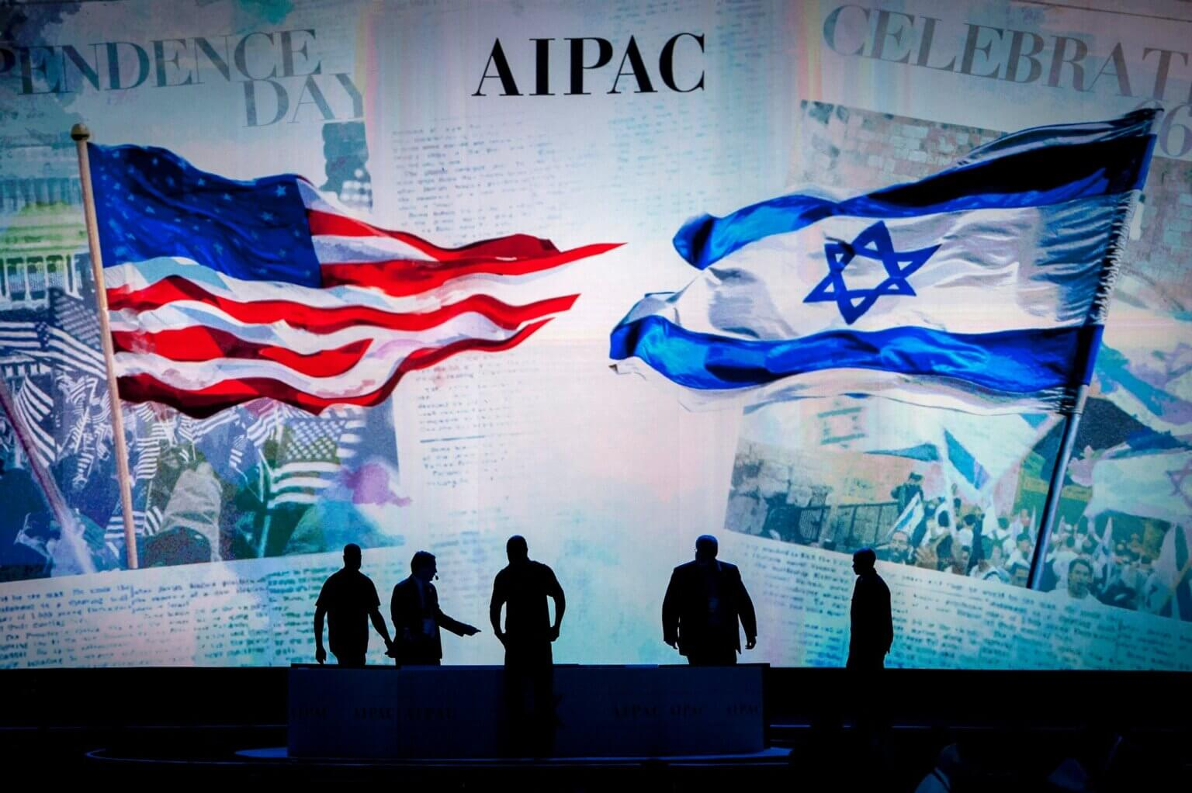

Workers put the finishing touches on the stage at the annual American Israel Public Affairs Conference in Washington in March 2015. (Photo: Pete Marovich European Pressphoto Agency)

Genocide in Gaza

🇮🇱 Tareq Hajjaj: Most Palestinians in Gaza say they don’t feel the relief they expected after the ceasefire. Israel keeps blocking aid into the strip, delaying reconstruction efforts, and leaving hospitals short on supplies, while people go hungry every day.
🇵🇸 Tareq Hajjaj: Yasser Abu Shabab had become an infamous figure in Gaza over the past two years for his role in collaborating with the Israeli army, looting aid convoys destined for starving Palestinians, and sowing social strife amid the genocide.

Catch-up

🫏 Mitchell Plitnick: As Hillary Clinton and Sarah Hurwitz blame the rising support for Palestine within the Democratic Party on social media, former Obama staffer Ben Rhodes makes clear why Democrats are turning on Israel and what this means for the party moving forward.
🇺🇸 Michael Arria: Last month, 16-year-old Palestinian-American Mohammed Ibrahim was finally released after nearly 10 months in an Israeli prison. His freedom follows a campaign by over 100 organizations pressuring the Trump administration to intervene on his behalf.
🏠 Qassam Muaddi: Palestinians displaced from refugee camps in the northern West Bank are demanding to return to their homes after an Israeli military takeover of the camps, and they fear that proposed U.S. plans for rebuilding the camps will completely erase them.
🇺🇳 Craig Mokhiber: The UN Security Council resolution backing the Trump plan for Gaza is clearly illegitimate, but there are several ways that states and individuals worldwide can challenge its illegality.
➡️ Matt Serif-Cullick: Recent comments by Tucker Carlson and Candace Owens have drawn more attention to right-wing critiques of U.S. support for Israel. However, it is a serious mistake for those on the left to see this anti-Israel criticism as "anti-Zionist."

