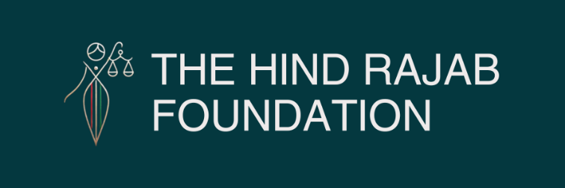

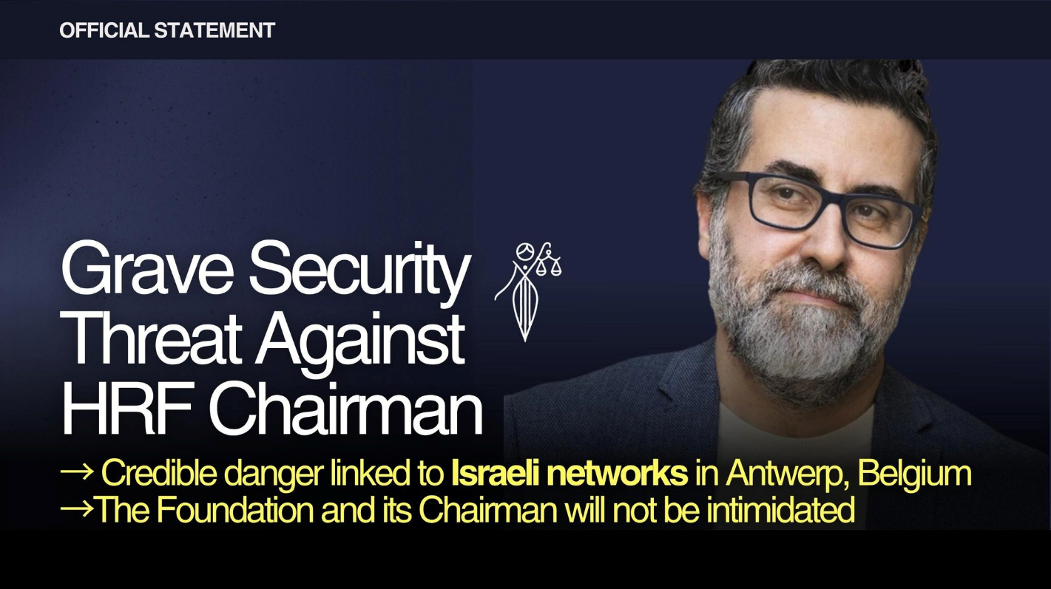

A serious and active security threat targets Hind Rajab Foundation Chairman Dyab Abou Jahjah and his family, linked to Israeli security networks in Antwerp.
Authorities have tightened protection measures. We will not be intimidated in our pursuit of justice.

Read the full press release below.

SUPPORT OUR WORK

Brussels- Septyember 25, 2025-

The Hind Rajab Foundation is gravely concerned about a serious and imminent security threat against our Chairman, Mr. Dyab Abou Jahjah, and his family.

Credible information indicates that individuals linked to Israeli security networks active in Antwerp, and with possible connections to extremist organizations such as the Jewish Defense League, are involved in this threat. There are also concerns that such structures may be connected to official Israeli state bodies.

While this is first and foremost a direct threat to the personal safety of Mr. Abou Jahjah and his family, it also constitutes a threat to the Hind Rajab Foundation and its work in seeking justice and accountability for war crimes and crimes against humanity in Palestine.

In light of these developments, the Belgian police and other security services have initiated measures, and the protective arrangements already in place for Mr. Abou Jahjah have been significantly tightened. The Hind Rajab Foundation and Mr. Abou Jahjah are fully collaborating with the relevant authorities to ensure that all necessary steps are taken.

The Hind Rajab Foundation and its Chairman will not be intimidated.
​We will continue our work undeterred, but we expect all levels of security and state protection to treat this situation with the urgency and seriousness it deserves.

