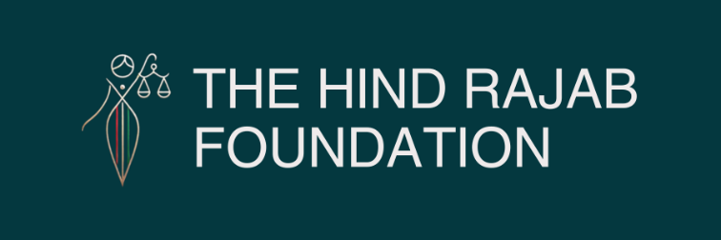



Two individuals accused of committing war crimes and genocide in Gaza are currently attending the Tomorrowland festival in Boom, Belgium. The Hind Rajab Foundation, in collaboration with the Global Legal Action Network (GLAN), has filed urgent legal complaints demanding their immediate arrest and prosecution.
Evidence shows their involvement in torture, mass killings, forced displacement, and the destruction of civilian infrastructure—acts that meet the legal definition of genocide.
Belgium, bound by the Genocide Convention and Rome Statute, has a legal duty to act under its universal jurisdiction laws. The suspects are planning to leave the country on Sunday. Action is needed now!

Read the full press release below.

SUPPORT OUR WORK

Brussels, Boom –
Two individuals responsible for grave international crimes—including war crimes and genocide committed in the Gaza Strip—are currently on Belgian soil, attending the Tomorrowland music festival in Boom. The Hind Rajab Foundation, in association with GLAN, has submitted urgent legal complaints to the Federal Prosecutor, calling for their immediate arrest and prosecution under Belgium's universal jurisdiction laws.
These individuals are not fringe actors or incidental participants. They are directly implicated in some of the most egregious crimes committed during Israel's ongoing military campaign in Gaza, including:
- Indiscriminate attacks on civilian areas, homes, and hospitals;
- The use of torture and human shields;
- Mass arbitrary detention and forced displacement of civilians;
- And the deliberate infliction of conditions calculated to destroy the Palestinian population, consistent with genocide under Article 6 of the Rome Statute and the Genocide Convention.

Givati Brigade Flag Waved

A group of young Israeli men were yesterday seen at Tomorrowland while waving the flag of the Israeli Givati Brigade—a unit extensively documented for its role in the systematic destruction of civilian infrastructure in Gaza and for carrying out mass atrocities against the Palestinian population.
The Givati flag, publicly displayed in the heart of Belgium, is not just a military symbol. It has become, for millions, a symbol of impunity, destruction, and ethnic cleansing. Its appearance in Boom raises urgent political questions:
Why are those involved in grave international crimes able to walk freely, celebrate in public, and glorify their actions without consequence?
The situation is not isolated. Just days ago, in Dirkputstraat in Boom, a Palestinian flag was forcibly torn down from a private residence by a group of young Israeli men of military age, in an act the resident described as deeply intimidating. The symbolism is stark: while war crimes suspects display their military insignia freely, the symbols of their victims are attacked.
This convergence—of impunity, intimidation, and silence—demands a clear response from Belgian society and its legal institutions.

A Legal Obligation, Not a Political Option

Belgium is bound by international law to investigate and prosecute individuals suspected of genocide and war crimes when they are present on its territory. These obligations arise from:
The Genocide Convention (1948),
The Rome Statute of the International Criminal Court (ratified by Belgium in 2000),
And the Belgian Penal Code, which incorporates universal jurisdiction over war crimes, crimes against humanity, and genocide.
A State Party is legally required to prosecute or extradite genocide suspects the moment they are found on its soil—regardless of nationality or rank.
The evidence presented by the Hind Rajab Foundation is clear, credible, and legally sound. The individuals currently in Belgium are accused of acts that:
Destroyed entire neighborhoods in Gaza under the guise of "security";
And deliberately targeted Gaza's capacity to survive—its water systems, agriculture, housing, and medical infrastructure.
"These actions were not incidental. They were executed with intent—to destroy a people, to erase a future" Said HRF's Chairman Dyab Abou Jahjah. "If Belgium allows these individuals to leave unchallenged, it will be complicit in granting impunity to the perpetrators of genocide" he added.

Belgium Must Act Now

Tomorrowland, a global stage of culture and celebration, must not become an unwitting sanctuary for war criminals.
Belgium has long prided itself on supporting international justice. That legacy is on the line.
We therefore urge:
- The immediate arrest of the individuals named in the complaints;
- The opening of formal investigations and prosecutions;
- And measures to prevent any departure from Belgian territory, including the seizure of travel documents and devices.
There is still time to act. But that time is quickly running out.

