

Israel is using militias to seize Gaza, and the DNC buried the genocide

On May 13, residents near al-Hikma Mosque in eastern Deir al-Balah began receiving phone calls from someone identifying himself as "Captain Abu Omar," an Israeli army officer, ordering them to evacuate within days. Hours later, armed fighters loyal to Shawqi Abu Nuseira — a militia leader residents say is armed and protected by the Israeli military — arrived with the same message. Tareq Hajjaj reports on how Israel is coordinating military orders and proxy militias to consolidate its seizure of Gaza, with Israeli forces now controlling 65% of the territory and residents calling the new partition line an "apartheid wall."
The genocide in Gaza must be understood not only as the culmination of Zionist settler colonialism, William I. Robinson and M. Gürsan Şenalp argue, but as a product of the epochal crisis of global capitalism. Gaza was the first AI war of the 21st century, and if Global Trumpism succeeds, it will become a testing ground for "Pax Silica," the merger of the high-tech military-surveillance complex with transnational finance capital.
The Israeli Knesset passed the first reading of the Antiquities Law this week, 23 to 14. The bill would transfer authority over West Bank Palestinian historical and archaeological sites from the Israeli army's Civil Administration to a civilian agency under the Ministry of Heritage. Qassam Muaddi reports on what the legislation means in practice, with Palestinian archaeologist Dr. Hamdan Taha calling it a deprivation of Palestinians' collective memory, cultural identity, and economic livelihood. Legal experts describe it as annexation in all but name.
America's decision to go to war with Iran, Yakov Hirsch argues, is best understood as the product of a narrative shaped by historical trauma and moral absolutism rather than any coherent strategic objective. In Hirsch's analysis, no one, other than Netanyahu, bears more responsibility for the success of this worldview than Jeffrey Goldberg, editor-in-chief of The Atlantic and former IDF soldier, whose decades of writing on Iran have replaced empirical analysis with what Hirsch calls "Hasbara Culture": the mythology of eternal Jewish victimhood.
The DNC finally released its 192-page autopsy of Joe Biden's Kamala Harris's 2024 campaign, and it does not mention Gaza once. Michael Arria reports on what the omission reveals about the Democratic Party leadership. Harris refused to distance herself from Biden on Israel, maintained the same weapons-to-Israel policy throughout the campaign, and said she couldn't think of anything she would do differently than him. The party's refusal to reckon with its support for the genocide, Arria argues, sets up another defeat in 2028.
Mondoweiss has spent two decades building independent coverage of Palestine that the mainstream press ignores and suppresses. Google is restructuring its search around AI, and it's expected to further reduce traffic to publisher websites — and independent outlets like ours will feel it most. We need our readers to step up. Please support us with a donation today!

 |  | David Reed, Publisher  Articles / Support our work today

📺 Watch: AIPAC has become TOXIC to both Democrats and Republicans

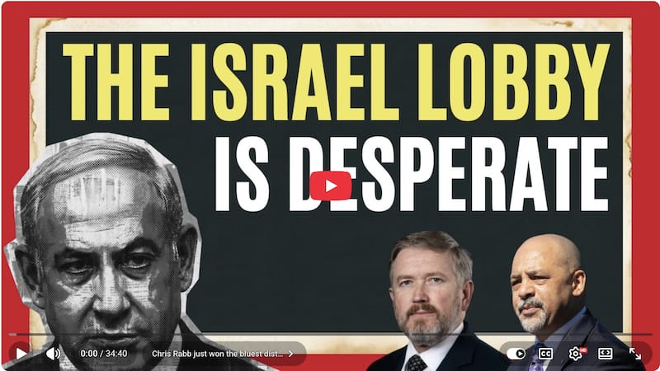

🇵🇸 Gaza

Israel's seizure of Gaza is proceeding on two tracks that the mainstream press treats as separate: the physical consolidation of territory through militias and concrete barriers, and the broader political-economic project the genocide is designed to serve.
READ MORE → How Israel is using militias and concrete blocks to seize what remains of Gaza — Tareq S. Hajjaj
READ MORE → Pax Silica, the Gaza genocide, and the crisis of global capitalism — William I. Robinson and M. Gürsan Şenalp

🇮🇱 "Greater Israel" / West Bank and Jerusalem

Israel's annexation of the West Bank and East Jerusalem is a multi-front campaign designed to consolidate control from the Jordan Valley to Jerusalem, advancing through legislation, property seizures, and the forced concentration of Palestinian communities .
READ MORE → Israel moves to annex Palestinian historical sites in the West Bank — Qassam Muaddi
READ MORE → Israel is reviving a 58-year-old government order to seize vital Palestinian properties in Jerusalem — Qassam Muaddi
READ MORE → Israel has a master plan to relocate thousands of Palestinian Bedouins to a giant ghetto — Shatha Hammad

🇺🇸 United States

The Israel lobby's grip on U.S. politics is under strain but not yet defeated. The DNC refuses to reckon with how its support for the genocide cost it in 2024, AIPAC is facing new electoral resistance, and the media narratives that paved the way for war with Iran remain largely intact.
READ MORE → With signs of a possible Iran deal within reach, pressure is mounting on Trump to return to war — Mitchell Plitnick
READ MORE → How Jeffrey Goldberg weaponized Jewish trauma to pave the way for war with Iran — Yakov Hirsch
READ MORE → It's the genocide, stupid — Michael Arria
READ MORE → AIPAC sends a message by defeating Massie in Kentucky, but takes a massive loss with Rabb's victory in Philadelphia — Michael Arria

🌍 Global reckoning

The genocide in Gaza is exposing contradictions that governments worldwide can no longer deflect. They are seen in Germany's "never again" doctrine, in South Africa's simultaneous ICJ leadership and coal exports to Israel, and in the political realignments playing out in Latin America.
READ MORE → Itamar Ben-Gvir is suddenly the villain of Israeli politics for one reason: he revealed Israel's true face to the world — Jonathan Ofir
READ MORE → How Gaza is exposing Germany's 'never again' myth — Frédéric Schneider
READ MORE → Will Colombia's upcoming presidential election stop the pro-Israel wave sweeping Latin America? — Ana Maria Monjardino
READ MORE → Activists demand South Africa stop supplying Israel with coal as a new report outlines complicity in the Gaza genocide — Riley Singh


Donate to power the next 20 years
For 20 years, Mondoweiss has covered the powers that sustain Israeli apartheid – and how people resist it, from Palestine to the U.S.
Become a donor today!

Wait! Before you go...

Mondoweiss is an independent, reader-funded publication. We publish stories and analysis about the struggle for freedom in Palestine that you will not find in corporate media. Our growing team relies on your support. Here are some ways you can help...
💸 Join our supporters and become a Mondoweiss donor today.
🗣️ Share Mondoweiss articles on X, Facebook, Instagram, or any other social media platform you are active on.
📺 Subscribe to our YouTube channel and help us reach 100,000 subscribers!
🛍️ Shop our online store! We offer a selection of union-printed t-shirts and totes, as well as several fascinating books. We also ship internationally.
📨 Forward this email to a friend.
🎧 Subscribe to our podcast anywhere you listen.

